Youth Prevalence:
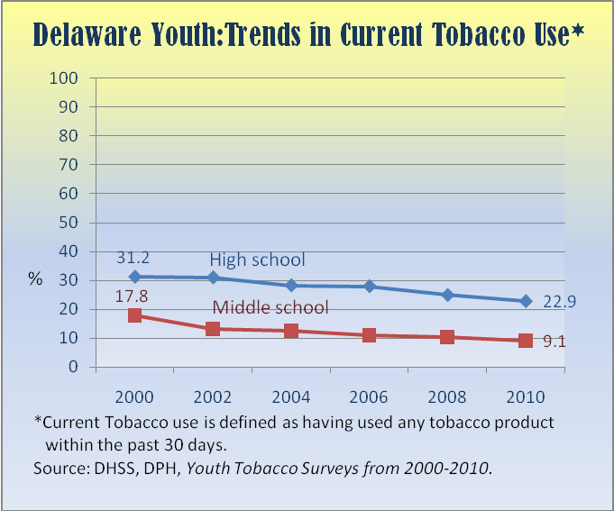
High School overall decrease = 26.6%
Middle School overall decrease = 48.9%

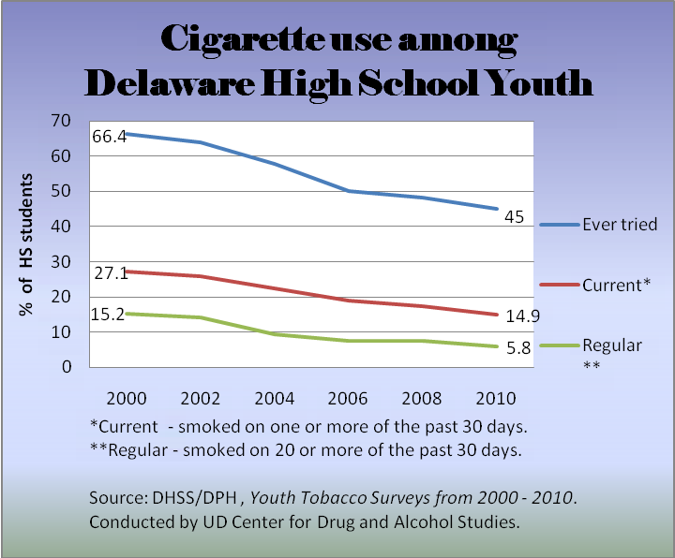
Ever tried overall decrease = 32.2%
Current use overall decrease = 45.0%
Regular use overall decrease = 61.8%
Quitline: Number of Calls and enrollment in telephone counseling
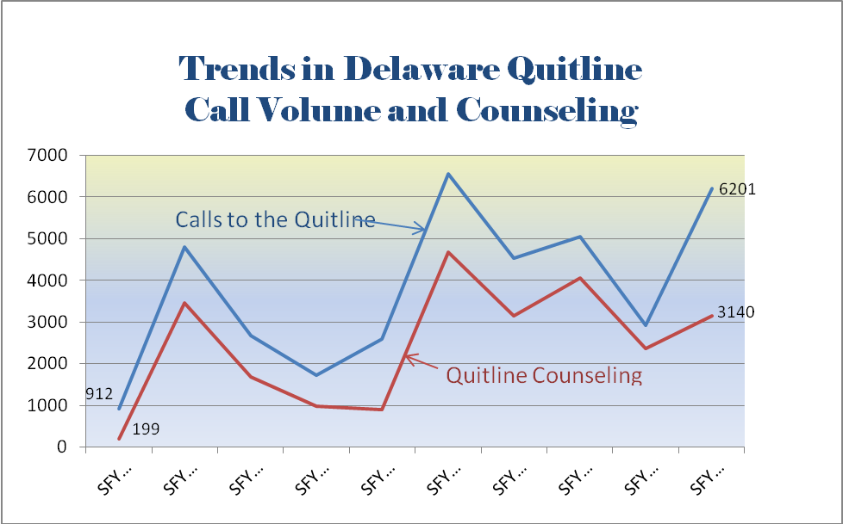

What works?

Social Marketing drives calls to the Quitline, helps educate people about the dangers of second-hand smoke, and helps promote the social norm of not smoking or using other tobacco products.
(see charts on next page)
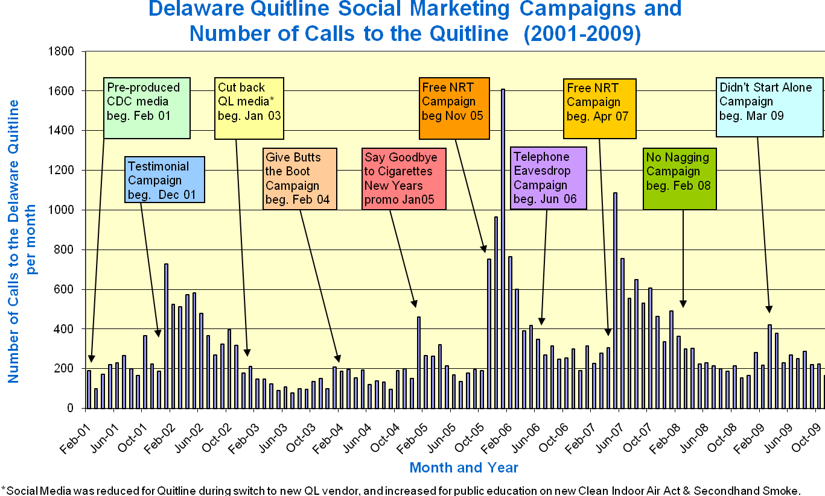

Overall awareness of the Quitline has increased among both smokers and non-smokers.
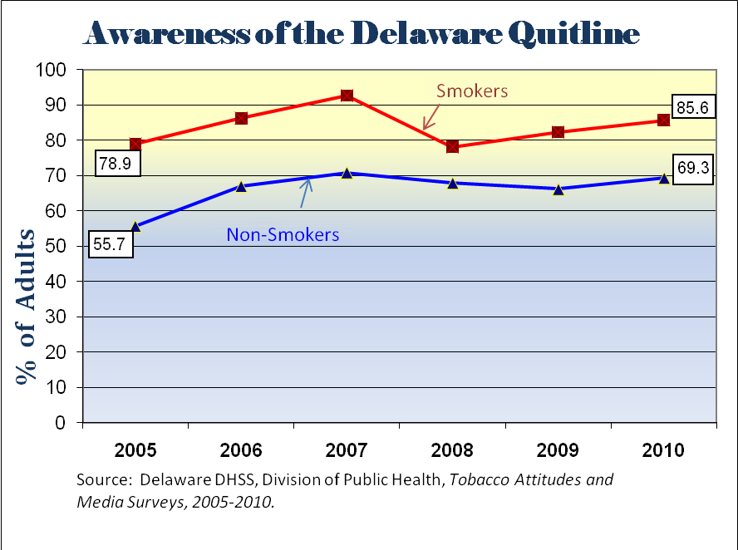
Public Education has increased awareness about the dangers of second-hand smoke:
- More than 90% adults agree or strongly agree with the statement:”People should be protected against second-hand smoke.” This includes 82% of every-day smokers and 87% of some-day smokers.
- Between 2002 and 2010 adults got tougher on rules about not smoking in their homes:
The proportion of adults reporting that smoking was not allowed anywhere nor at anytime inside the home increased from 68% in 2002 to 78.7% in 2010. At the same time, the percentage allowing smoking in some locations or at some times dropped from 12.3% to 8.4%, and the percentage allowing smoking anywhere at any time declined from 5.4% to 1.9%. The percent with no rules about smoking inside the home also fell from 14.3% to 11.5%.
(Sources: Delaware’s Behavioral Risk Factor Surveillance Survey, 2002, and Tobacco Attitudes and Media Survey, 2010.)
- More than 60% of adults believe that smoking should not be allowed outside of entrances to buildings and at outdoor restaurant dining patios. (Tobacco Attitudes and Media Survey, 2010)
Youth Prevention and Community Outreach Programs are aimed at preventing youth initiation to tobacco use. These efforts have lead to:
- Decrease in prevalence of youth who have ever tried tobacco products (aka “Lifetime use of Tobacco”)
- Increase in the proportion of young adults who have never smoked cigarettes
(Charts follow)
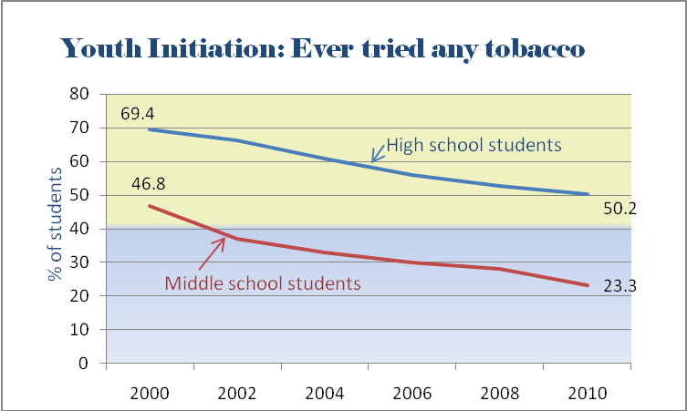
High School overall decrease = 27.7%
Middle School overall decrease = 50.2%

At the same time, the percentage of 18-25 year olds who have never smoked cigarettes began to go up in 2002

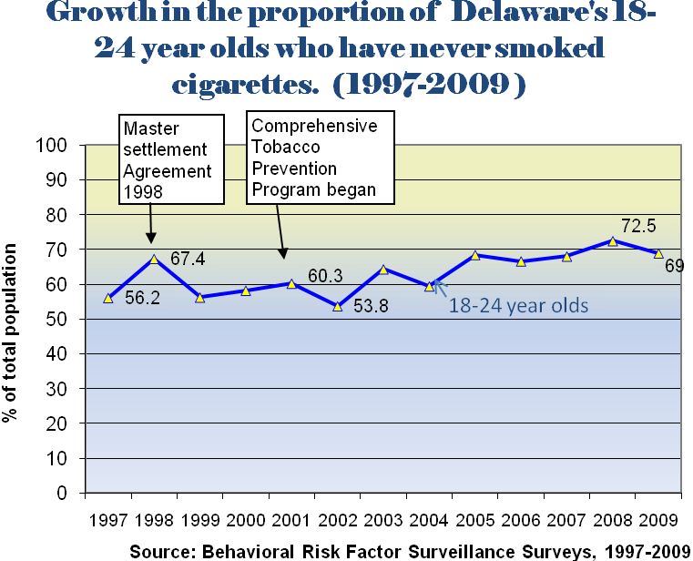
Overall increase = 22.8%

- Better understanding of the risks associated with tobacco use.
Between 2000 and 2010, the percent of Middle school students who believe that “it’s safe to smoke for a year or two, as long as you quit after that” dropped from 15.4% to 11.9%, while the rates among High school students declined from 14.2% to 12.5%.
Reducing tobacco use among adults:
Provider packets encouraging physicians to ask about tobacco use and advise their patients to quit were distributed in 2002. The proportion of adults reporting that their doctors advised them to quit smoking rose from 48% in 2000 to 79% in 2002.
Between 2-3% of tobacco users enroll in cessation programs each year. (Nationally, the figure is less than 2%.*) After a decade of DE Quitline operation, more than 34,250 tobacco users have enrolled in telephone or in-person counseling services offered through DPH. Most recent assessment- 22% of those who received counseling reported remaining quit after seven months (30-day point prevalence quit rates).
Not all tobacco users use services provided to quit. Many quit on their own. Some just call the Quitline to obtain information or self-help kits. Others pay attention to doctor’s advice to quit. However, the comprehensive tobacco prevention program helps provide the motivation to quit by creating a social environment where non-smoking and non-tobacco use are the norm.
From the BRFSS surveys, we estimate that there were 30,800 more “former smokers” in 2009 than there would have been based upon their proportion of the 2000 adult population.

Personnel Position List for DPH Tobacco Application
Merit Title | Program | Position
Public Health Treatment Program Administrator | Comprehensive Cancer Control | Comprehensive Cancer Program Director
Trainer/ Educator III | Comprehensive Cancer Control | Trainer/Educator
Epidemiologist | Epidemiology- Program Consultation | Epidemiologist
Public Health Treatment Program Administrator | Health Systems Protection- Office of Health Environments | Office of Healthy Environments Program Administrator
Public Health Treatment Program Administrator | Physical Activity, Nutrition and Obesity Prevention | Physical Activity, Nutrition and Obesity Prevention Program Administrator
Management Analyst III | Tobacco Prevention and Control | Tobacco Prevention and Control Program Evaluator
Social Services Administrator | Tobacco Prevention and Control | Tobacco Prevention and Control Program Coordinator
Social Services Administrator | Comprehensive Cancer Control | Social Services Administrator

