Instructions for Launching the eSTAR Curriculum on Delaware Learning Center
- Log-in to the Delaware Learning Center: http://www.delawarepersonnel.com/training/index.shtml
- Once on the website you can go on through the State Single Sign-on, attached is a job aid.
- From your home screen you can search DHSS eSTAT in the Universal Search box in the upper right corner.
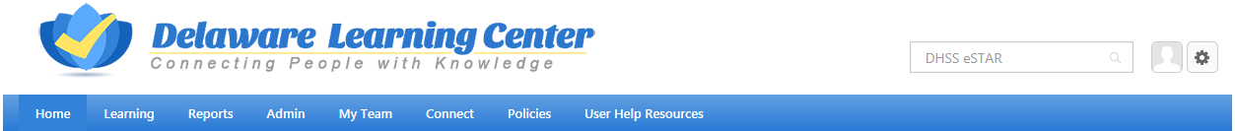
- The training results will show:
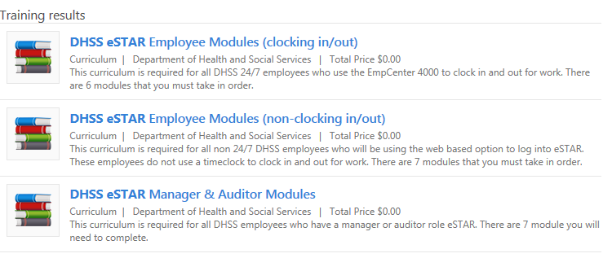NOTE: The stack of books icon helps to identify that it is a curriculum.
- Select the employee curriculum that best suits your division before completing the Manager & Auditor curriculum.
- Once opened, click Request.
- Next you go to your transcript.
- You will see the curriculum you selected displayed, from here click register.
- Next click Open Curriculum.
- Then select Activate.
- Select Launch training.
- You must complete the courses in order.
- Your course progress for module is tracked in the Delaware Learning Center.

If you have any issues navigating please let me know. Keep in mind that you can click on the menu to move or go back within the CBT training.

