**CANCER INCIDENCE AND MORTALITY   
IN DELAWARE, 2017-2021**

DELAWARE DEPARTMENT OF HEALTH AND SOCIAL SERVICES

DIVISION OF PUBLIC HEALTH

2024





This report is made possible with funding from the Delaware Health Fund, with   
strategic leadership and guidance provided by the Delaware Cancer Consortium.

This report was prepared by the Delaware Department of Health and Social Services, Division of Public Health, Comprehensive Cancer Control Program.

For more information, contact:

Delaware Comprehensive Cancer Program

Division of Public Health

Thomas Collins Building, Suite 11

540 S. DuPont Highway

Dover, DE 19901

Phone: 302-744-1020

Fax: 302-739-2545

<http://www.dhss.delaware.gov/dhss/dph/dpc/cancer.html>

# Table of Contents

Executive Summary 3

Chapter 1: Introduction 6

Chapter 2: All-Site Cancer 12

Chapter 3: Site-Specific Cancer 30

Appendix A: Data Sources and Methodology 44

Appendix B: Primary Cancer Site Definitions 50

Appendix C: Hispanic Ethnicity 52

Appendix D: Early Detection 54

Appendix E: Behavioral Risk Factors 58

# Executive Summary

This report presents the 2017-2021 cancer incidence and mortality data and statistics for Delaware. The Delaware Department of Health and Social Services (DHSS), Division of Public Health (DPH), in conjunction with the Delaware Cancer Consortium (DCC), publishes this report as a source of cancer incidence and mortality information. DPH and other stakeholders also use this report to inform decisions on outreach and program strategies to combat cancer incidence and mortality in Delaware.

Cancer incidence (the number of new cancer cases in a population over a time period)[1] and mortality (the number of deaths from cancer in a population over a time period)[2] rates and other analyses are performed by the Delaware Bureau of Cancer Prevention and Control staff. Incidence data are obtained from the Delaware Cancer Registry (DCR) and mortality data are obtained from the Delaware Health Statistics Center.

This report includes cancer statistics for all cancer sites combined (all-site cancer), as well as the top 23 site-specific cancer types: brain and other nervous system, cervix, colorectal, esophagus, female breast, Hodgkin lymphoma, kidney and renal pelvis, larynx, leukemia, liver and intrahepatic bile duct, lung and bronchus, melanoma, myeloma, non-Hodgkin lymphoma, ovary, oral cavity and pharynx, pancreas, prostate, stomach, testis, thyroid, uterine, and urinary bladder. These cancer statistics reflect incidence and mortality data for 2017-2021. DPH compares Delaware’s cancer incidence and mortality statistics for 2017-2021 to those of the U.S. over the same period. DPH also summarizes how Delaware and U.S. cancer rates have changed from 2007 to 2021.

**INCIDENCE**

Between 2007 and 2021, incidence rates for all-site cancer decreased by an average of 1.1% per year in Delaware and an average of 0.7% per year in the U.S. While progress continues to be made, Delaware’s 2017-2021 all-site cancer incidence rate (462.1 per 100,000 population) remains higher than the comparable U.S. rate (444.6 per 100,000 population). Delaware currently ranks 15th among the states for highest all-site cancer incidence. Between 2007 and 2021, incidence rates for all-site cancer decreased an average of 1.8% per year among non-Hispanic White males and remained stable for non-Hispanic White females. During that same period, incidence rates for all-site cancer decreased an average of 3.0% per year among non-Hispanic Black males and remained stable among non-Hispanic Black females. Incidence rates for all-site cancer decreased an average of 2.9% per year among Hispanic males and remained stable among Hispanic females in Delaware between 2007 and 2021.

In 2017 to 2021, there were 30,849 new all-site cancer cases diagnosed, an average of 6,169 per year in Delaware. Of the 23 site-specific cancers analyzed, female breast cancer accounted for 17% of all new cancer cases, followed by lung and bronchus cancer, which accounted for 14% of all new cancer cases. During 2017-2021:

* Delaware females had a statistically significantly lower age-adjusted incidence rate compared to Delaware males for colon and rectum (colorectal), esophagus, kidney and renal pelvis, larynx, leukemia, liver and intrahepatic bile duct, lung and bronchus, melanoma, myeloma, non-Hodgkin lymphoma, oral cavity and pharynx, pancreas, stomach, and urinary bladder.
* Delaware females had a statistically higher incidence rate for thyroid cancer compared to Delaware males.
* There was statistically no difference in the age-adjusted incidence rate among Delaware females compared to Delaware males for brain and other nervous system and Hodgkin lymphoma cancers.
* Non-Hispanic Black Delawareans had a statistically significantly higher age-adjusted incidence rate compared to non-Hispanic White Delawareans for the following cancers: stomach, liver and intrahepatic bile duct, pancreas, myeloma, and prostate cancers.
* Non-Hispanic Black Delawareans had a statistically significantly lower age-adjusted incidence rate compared to non-Hispanic White Delawareans for oral cavity and pharynx, esophagus, lung and bronchus, urinary bladder, brain and other nervous system, thyroid, non-Hodgkin lymphoma, leukemia, and ovarian cancers.
* Non-Hispanic Black Delawareans had statistically no difference in age-adjusted incidence rates compared to non-Hispanic White Delawareans for all-sites, colon and rectum (colorectal), larynx, kidney and renal pelvis, Hodgkin lymphoma, female breast, cervical, and uterine cancers.
* Hispanic Black Delawareans had a statistically significantly higher age-adjusted incidence rate compared to non-Hispanic White Delawareans for stomach and liver and intrahepatic bile duct cancers.
* Hispanic Delawareans had a statistically significantly lower age-adjusted incidence rate compared to non-Hispanic White Delawareans for all-sites, oral cavity and pharynx, colon and rectum (colorectal) lung and bronchus, urinary bladder, prostate, and female breast cancers.
* Hispanic Delawareans had statistically no difference in age-adjusted incidence rates compared to non-Hispanic White Delawareans for pancreas, kidney and renal pelvis, non-Hodgkin lymphoma, brain and other nervous system, myeloma, leukemia, uterine, and ovarian cancers.

**MORTALITY**

In 2017-2021, the Delaware all-site cancer mortality rate of 154.1 per 100,000 population was higher than the U.S. rate of 148.4 per 100,000 population. Although Delaware’s all-site cancer mortality rate has historically been higher than the U.S. rate, the gap narrowed over the last decade as the state continues to make strides in reducing the cancer mortality rate through cancer screening and early detection. Delaware ranks 16th among the states for highest all-site cancer mortality, which is an improvement compared to the 2016-2020 time period, when Delaware ranked 15th. This represents considerable continued progress since the 1990s, when the state ranked second. In the 15-year period between 2007 and 2021, mortality rates for all-site cancer decreased an average of 1.8% per year in Delaware and decreased an average of 1.5% per year in the U.S.

Between 2007 and 2021, mortality rates for all-site cancer decreased by an average of 1.6% per year among non-Hispanic White males and decreased by an average of 2.0% per year among non-Hispanic White females. Between 2007 and 2021, mortality rates for all-site cancer decreased by an average of 1.7% per year among non-Hispanic Black males and remained stable for non-Hispanic Black females. Between 2007 and 2021, the trend in mortality rates for all-site cancer was stable among both Hispanic males and Hispanic females in Delaware.

In 2017-2021, there were 10,453 deaths from cancer, an average of 2,090 per year in Delaware. Of the 23 site-specific cancers, lung and bronchus cancer accounted for 28% of all new cancer deaths. The second leading cause of cancer death was colorectal cancer, which accounted for 9% of all new cancer deaths; and pancreatic cancer, which accounted for 9% of all new cancer deaths. During 2017-2021:

* Delaware females had a statistically significantly lower age-adjusted mortality rate compared to Delaware males for the following cancers: all-sites, brain and other nervous system, colon and rectum (colorectal), esophagus, kidney and renal pelvis, larynx, leukemia, liver and intrahepatic bile duct, lung and bronchus, melanoma, myeloma, non-Hodgkin lymphoma, oral cavity and pharynx, pancreas, stomach, and urinary bladder.
* Non-Hispanic Black Delawareans had a statistically significantly higher age-adjusted mortality rate compared to non-Hispanic White Delawareans for all-sites, stomach, larynx, liver and intrahepatic bile duct, pancreas, myeloma, female breast, prostate, and uterine cancers.
* Non-Hispanic Black Delawareans had a statistically significantly lower age-adjusted mortality rate compared to non-Hispanic White Delawareans for brain and other nervous system and esophagus cancers.
* Non-Hispanic Black Delawareans had statistically no difference in age-adjusted mortality rates compared to non-Hispanic White Delawareans for oral cavity and pharynx, colon and rectum (colorectal), lung and bronchus, urinary bladder, kidney and renal pelvis, non-Hodgkin lymphoma, leukemia, cervical, and ovarian cancers.
* The age-adjusted mortality rate for stomach cancer among Hispanic Delawareans (9.9 deaths per 100,000 population) was statistically significantly higher compared to non-Hispanic White Delawareans (2.3 deaths per 100,000 population).
* Hispanic Delawareans had a statistically significantly lower age-adjusted mortality rate compared to non-Hispanic White Delawareans for all-sites, lung and bronchus, and female breast cancers.
* Hispanic Delawareans had statistically no difference in age-adjusted mortality rates compared to non-Hispanic White Delawareans for colon and rectum (colorectal), liver and intrahepatic bile duct, and non-Hodgkin lymphoma cancers.

# Introduction

### **Delaware Cancer Registry**

The Delaware Cancer Registry (DCR) is managed by the Delaware Department of Health and Social Services (DHSS), Division of Public Health (DPH) and serves as the state’s central cancer information center. The DCR was founded in 1972 and was legally established in 1980 under the Delaware Cancer Control Act[3]. The Act stipulated that all state hospitals, clinical laboratories, and cancer treatment centers report all new cancer cases to the DCR. In 1996, the Delaware Cancer Control Act was amended to require any health care practitioner who diagnoses or provides treatment to report cancer cases to the DCR. Further enhancements of the Delaware Cancer Control Act took effect in 2002 with the passage of Senate Bill 372 which requires physicians to provide additional information to the DCR, including patients’ duration of residence in Delaware and their occupational history. Senate Bill 372 also extended the reporting deadline to 180 days from initial diagnosis or treatment.

Today, Delaware is one of 46 states whose central cancer registry is supported by the National Program of Cancer Registries (NPCR) of the U.S. Centers for Disease Control and Prevention (CDC).[4] The DCR ensures accurate, timely, and routine surveillance of cancer trends among Delawareans.

### **Reporting Facilities**

Seven Delaware hospitals currently report cancer cases to the DCR.  Non-hospital offices that submit data to the DCR include 15 diagnostic laboratories, 13 freestanding ambulatory surgery centers, and at least 20 physicians.  Additionally, the DCR has reciprocal data exchange agreements with Alaska, Alabama, Arizona, Arkansas, California, Colorado, Connecticut, Florida, Georgia, Hawaii, Idaho, Illinois, Indiana, Louisiana, Maine, Maryland, Massachusetts, Michigan, Minnesota, Missouri, Montana, Nebraska, Nevada, New Hampshire, New Jersey, New York, North Carolina, Ohio, Oklahoma, Pennsylvania, Puerto Rico, Rhode Island, South Carolina, South Dakota, Tennessee, Texas, Utah, Vermont, Virginia, Washington, West Virginia, Wisconsin, Wyoming, and the District of Columbia.  Interstate data exchange agreements assist in identifying Delaware residents whose cancer was diagnosed and/or treated in another state.

### **Data Confidentiality**

The DCR maintains patient confidentiality using a combination of techniques. Reporting facilities submit cancer data using computerized data encryption techniques. Published reports are limited to aggregate data, and requests for data releases are all reviewed by the DPH Privacy Board and need to be approved before release. Researchers who use DCR data must comply with regulations stated in DPH data use agreements and in some cases, obtain clearance from Delaware’s Human Subjects Review Board.

### **Data Quality**

The DCR implements internal quality control procedures to verify the consistency of cancer data continually throughout the year as data are submitted by reporting facilities. In addition, the DCR strives to meet data consistency standards set by the North American Association of Central Cancer Registries (NAACCR). Data are submitted by DCR to NAACCR annually. The DCR also conducts record consolidation using a computerized matching program to identify multiple reports on the same individual. This scenario often arises when a patient is diagnosed and treated in two or more facilities, and each facility submits a cancer case reporting form to the DCR.

### **NAACCR Certification and NPCR Standard Status**

In 1997, the NAACCR instituted a program to independently and annually review data from member registries for their completeness, accuracy, and timeliness. The registry certification metrics are pre-determined and established by NAACCR[5]. Gold or Silver Standard certifications are awarded following an evaluation of data quality, completeness, and timeliness of reporting. The DCR received Gold Standard certification for diagnosis in 1999, 2003, 2004, 2005, 2006, 2007, 2008, 2009, 2010, 2011, 2012, 2013, 2014, 2015, 2016, 2017, 2018, 2019, 2020, and 2021 (the most recent year for which complete data are currently available). The DCR received Silver Standard certification in 1998 and 2002.

Additionally, the NPCR provides an annual Standard Status Report to state cancer registries supported by the CDC. Delaware’s data submissions for diagnosis years 2000 through 2021 surpassed all standard levels for quality, completeness, and timeliness.

### **Uses of Data**

DPH uses DCR data to support various programs and initiatives, including the Screening for Life (SFL) program and the Delaware Cancer Treatment Program. DPH also uses DCR data to investigate citizen inquiries and provide up-to-date cancer statistics to Delaware residents, hospitals, health care providers, community organizations, federal agencies, research institutions, and academic institutions. Committees associated with the Delaware Cancer Consortium (DCC) utilize DCR data to monitor cancer trends across the state, promote research, and guide policy planning.

### **COVID-19 impact on cancer incidence**

The DCR and U.S. data utilized for this report include cancer cases diagnosed in 2020, the first year of the Coronavirus 2019 (COVID-19) pandemic. The pandemic resulted in delays and reductions in cancer screening and diagnosis, which subsequently led to a decline in 2020 incidence counts and rates, leading DPH to consider 2020 a temporary, anomalous year. Inclusion of 2020 rates would bias the estimates of trends over time, and therefore, 2020 rates were not included in trend analysis.[6]

Caution should be taken when making comparisons of cancer incidence data that include 2020 with other time periods, as decreases in incidence counts and rates may primarily be due to the effects of COVID-19 rather than decreases due to cancer control efforts.

### **Organization of This Report**

This report includes cancer statistics for all cancer sites combined (all-site cancer) and the top 23 site-specific cancers. Cancer statistics reflect incidence and mortality data for 2017-2021. Delaware’s cancer incidence and mortality statistics for 2017-2021 are compared to the U.S. over the same time period. Changes in Delaware and U.S. cancer incidence and mortality rates are shown from 2007 through 2021 using Joinpoint trend analysis. While 2020 is included in the graphs, 2020 data are not utilized for trend analysis since this year would bias estimates of trends over time. In addition to incidence and mortality, age-specific statistics are presented. In many cases, these statistics are also often calculated separately by sex, race, county of residence, and age group.

Data regarding cancer screening recommendations and compliance are presented in Appendix D. Behavioral risk factor data relevant to adult Delawareans are presented in Appendix E.

Delaware’s 2017-2021 cancer incidence and mortality rankings among all 50 U.S. states are provided for each cancer site included in the report. State rankings for cancer incidence and mortality were obtained from the National Cancer Institute’s CI*Rank[7].

### **Delaware’s Population**

In 2017-2021, census data estimated Delaware’s total average population at 981,892. Approximately 58% of Delawareans reside in New Castle County. Kent and Sussex counties are home to 18.3% and 23.8% of Delawareans, respectively (Figure 1-1).

**Figure 1‑1: percentage of population by county, Delaware, 2017-2021**

*Source: U.S. Census Bureau, 2017-2021 American Community Survey 5-Year Estimates,* [*https://data.census.gov/*](https://data.census.gov/)

Since 2000, population growth rates have varied across Delaware counties (Figure 1-2). New Castle County is Delaware’s most populated county. New Castle County experienced the smallest population growth from 2010 to 2020, while Sussex County experienced the largest population growth from 2010 to 2020.

**Figure 1‑2: PERCENTAGE OF POPULATION GROWTH BY COUNTY AND DECADE, DELAWARE,**

**2000-2010 and 2010-2020**

*Source: U.S. Census Bureau 2020,* [*https://data.census.gov/*](https://data.census.gov/)

Census data from 2017-2021 show that the majority of Delawareans are non-Hispanic White (60.8%), followed by non-Hispanic Black (21.5%), then Hispanic (9.7%) (Table 1-1).

**Table 1‑1: PERCENTAGE OF POPULATION BY RACE/ETHNICITY AND COUNTY, DELAWARE, 2017-2021**

|  |  |  |  |  |
| --- | --- | --- | --- | --- |
| Race/Ethnicity | Delaware | Kent  County | New Castle  County | Sussex  County |
| Not Hispanic or Latino |  |  |  |  |
| White | 60.8% | 59.6% | 55.5% | 74.6% |
| Black | 21.5% | 25.2% | 24.7% | 11.0% |
| American Indian and Alaska Native | 0.2% | 0.4% | 0.1% | 0.3% |
| Asian | 4.0% | 2.1% | 5.7% | 1.3% |
| Native Hawaiian and Other Pacific Islander | 0.0% | 0.0% | 0.0% | 0.0% |
| Other race | 0.4% | 0.4% | 0.3% | 0.4% |
| Two or more races | 3.3% | 4.7% | 3.0% | 3.0% |
| Hispanic or Latino | 9.7% | 7.5% | 10.5% | 9.4% |

*Source: U.S. Census Bureau, 2017-2021 American Community Survey 5-Year Estimates,* [*https://data.census.gov/*](https://data.census.gov/)

Since 2010, racial diversity has expanded at different rates across Delaware’s counties. Both Kent and New Castle counties experienced increases in the proportion of non-Hispanic Black and Hispanic residents (and concurrent decreases in the proportion of non-Hispanic White residents) from 2010 to 2020 (Figure 1-3). A different trend was observed in Sussex County, where the non-Hispanic Black population decreased from 2010 to 2020. However, similar to the trends in the other counties, the non-Hispanic White population declined while the Hispanic population increased.

**Figure 1‑3: PERCENTAGE OF RESIDENTS BY RACE/ETHNICITY,**

**DELAWARE COUNTIES, 2010 and 2020**

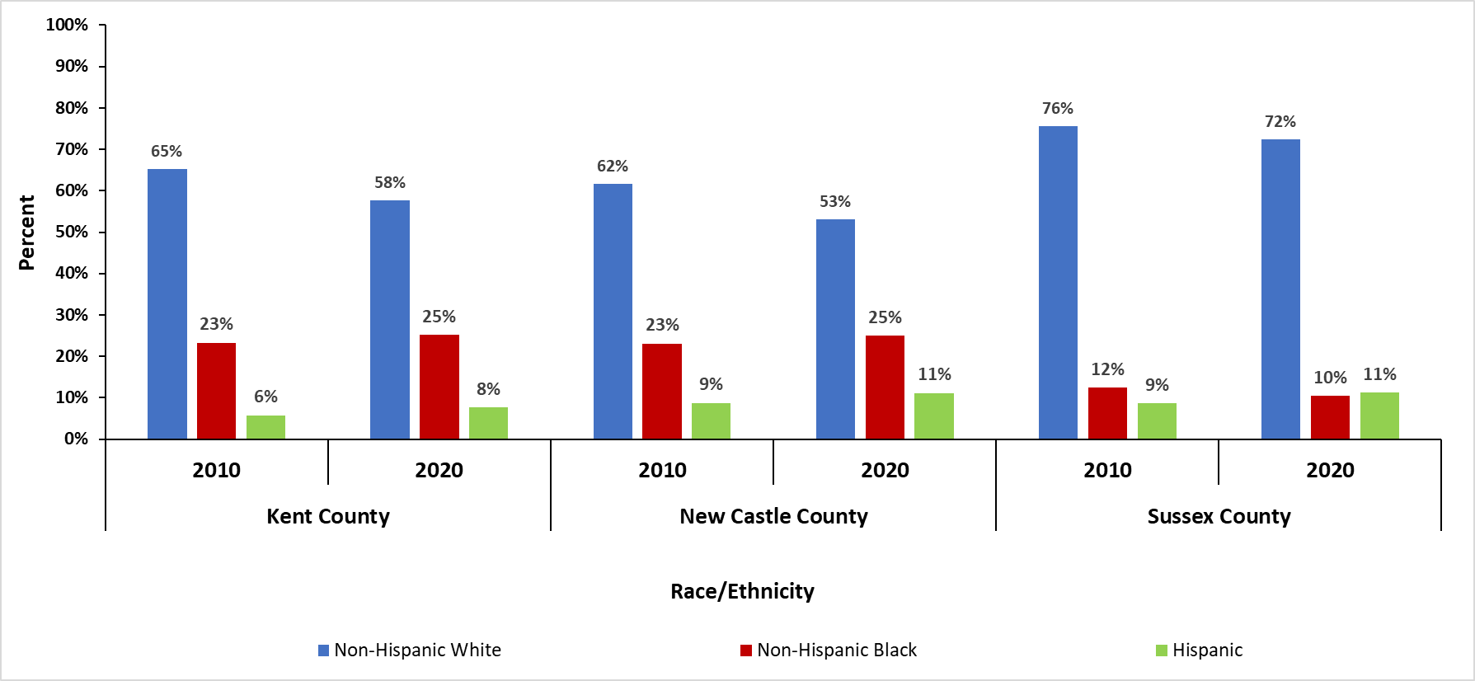

*Source: U.S. Census Bureau 2020,* [*https://data.census.gov/*](https://data.census.gov/)

### **Guidelines for Interpretation of Incidence and Mortality Rates**

Incidence and mortality rates for Delaware are expressed per 100,000 Delawareans and rates for the U.S. are expressed per 100,000 U.S. residents. Due to Delaware’s small population base, cancer rates were calculated using five-year calendar year groupings for both cancer incidence and mortality.

Cancer incidence and mortality rates were adjusted by age to enable comparisons between populations that may have different age distributions (e.g., Delaware vs. the U.S.). Thus, age-adjusted cancer rates can be compared without any concern about how differences in age distribution of the populations would affect cancer rates. The standard population used to adjust for age is the 2000 U.S. population.

Ninety-five percent confidence intervals were computed for each cancer rate. Rates based on fewer cases will have a wider confidence interval, while rates based on many cases will have a narrower confidence interval. Confidence intervals represent the range of values in which the cancer rate could reasonably fall 95% of the time. While confidence intervals can be helpful to explore potential differences between populations, identifying statistically significant differences by overlapping confidence intervals alone is subject to Type I and Type II errors more often than standard hypothesis testing. Therefore, in this report rates between two or more populations with confidence intervals that do not overlap have an incidence rate ratio calculated. If both the confidence interval method and the incidence rate ratio prove to be statistically significant at the p <0.05 level, these differences are determined to be confirmed and written as such in the body of the document.

For this report, cancer frequencies and rates were suppressed according to the CDC’s United States Cancer Statistics Suppression of Rates[8] and:

* Incidence and mortality frequencies of fewer than 16 were not shown to protect patient privacy and confidentiality. In some instances, additional cells were suppressed so that one cannot deduce the actual count in the initially suppressed cell. Suppressing incidence and mortality statistics based on a small number of cancer cases or deaths helps protect patient privacy and confidentiality.[9],[10]
* Age-adjusted incidence and mortality rates based on fewer than 16 cases or deaths were suppressed as they are inherently unstable and cannot be reliably interpreted.

# All-Site Cancer

## Incidence

|  |
| --- |
| For 2017-2021, Delaware ranked 15th in the U.S. for all-site cancer incidence (20th in 2016-2020); males ranked 16th (16th in 2016-2020) and females ranked 26th (19th in 2016-2020)[11]. |

2017-2021 Data

**Table 2‑1: Number of All-site CANCER CASES, BY SEX AND RACE/ETHNICITY;**

**Delaware and Counties, 2017-2021**

|  |  |  |  |  |  |  |  |  |  |  |  |  |
| --- | --- | --- | --- | --- | --- | --- | --- | --- | --- | --- | --- | --- |
|  | All Races | | | Non-Hispanic White | | | Non-Hispanic  Black | | | Hispanic | | |
|  | **All** | **Male** | **Female** | **All** | **Male** | **Female** | **All** | **Male** | **Female** | **All** | **Male** | **Female** |
| Delaware | 30,849 | 15,842 | 15,007 | 23,540 | 12,157 | 11,383 | 5,174 | 2,618 | 2,556 | 1,017 | 450 | 567 |
| Kent | 5,649 | 2,979 | 2,670 | 4,126 | 2,117 | 1,955 | 1,157 | 610 | 547 | 176 | 88 | 88 |
| New Castle | 15,653 | 7,705 | 7,948 | 10,980 | 5,408 | 5,572 | 3,339 | 1,648 | 1,691 | 637 | 278 | 359 |
| Sussex | 9,513 | 5,139 | 4,374 | 8,400 | 4,559 | 3,841 | 678 | 360 | 318 | 204 | 84 | 120 |

*Source: Delaware Department of Health and Social Services, Division of Public Health, Delaware Cancer Registry, 2024*

*Note: ‘All Races’ includes non-Hispanic White, non-Hispanic Black, and Hispanic which are shown in the table, as well as other racial/ethnic groups that are not included in the table (e.g., non-Hispanic Asian and Pacific Islander, non-Hispanic American Indian/Alaska Native, unknown race/ethnicity, and other non-specified race).*

* In Delaware in 2017-2021:
* There were 30,849 new all-site cancer cases diagnosed, an average of 6,169 per year.
* Males accounted for 51% of all-site cancer cases.
* Non-Hispanic White Delawareans accounted for 79% of all-site cancer cases.

**Table 2‑2: FIVE-YEAR Average Age-Adjusted All-site cancer Incidence Rates Overall and by Sex; U.S., Delaware, and Counties, 2017-2021**

|  |  |  |  |
| --- | --- | --- | --- |
|  | Overall | Male | Female |
| U.S. | 444.6 | 481.3 | 421.3 |
| Delaware | 462.1 | 502.5 | 433.9 |
| Kent | 498.5 | 560.7 | 451.2 |
| New Castle | 451.8 | 482.1 | 433.7 |
| Sussex | 460.9 | 504.4 | 427.7 |

*Source (Delaware): Delaware Department of Health and Social Services, Division of Public Health, Delaware Cancer Registry, 2024*

*Source (U.S.):* National Program of Cancer Registries and Surveillance, Epidemiology, and End Results Program SEER*Stat Database: U.S. Cancer Statistics 2001–2021 Public Use Research Database, 2023 submission.

Rates are per 100,000 of population age-adjusted to the 2000 U.S. standard population.

**Figure 2‑1: FIVE-YEAR AVERAGE AGE-ADJUSTED ALL-SITE CANCER INCIDENCE RATES BY SEX AND RACE/ETHNICITY; U.S. and Delaware, 2017-2021**

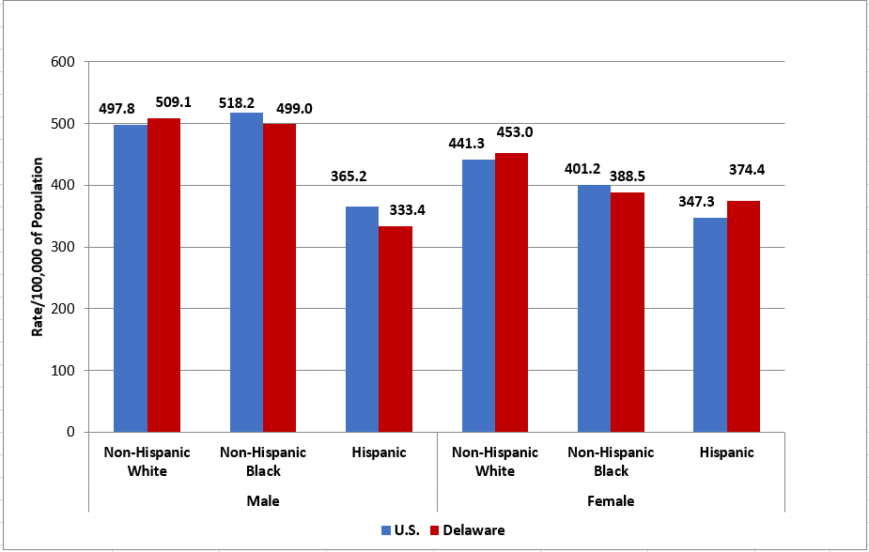

*Source (Delaware): Delaware Department of Health and Social Services, Division of Public Health, Delaware Cancer Registry, 2024*

*Source (U.S.):* National Program of Cancer Registries and Surveillance, Epidemiology, and End Results Program SEER*Stat Database: U.S. Cancer Statistics 2001–2021 Public Use Research Database, 2023 submission

Rates are per 100,000 of population age-adjusted to the 2000 U.S. standard population and are calculated using modified U.S. Census populations available from NCI (<https://seer.cancer.gov/popdata/>).

* In Delaware from 2017-2021:
  + Males (502.5 per 100,000 population) had a statistically significantly higher all-site cancer incidence rate compared to females (433.9 per 100,000 population).
  + The difference in all-site cancer incidence rates between non-Hispanic White Delawareans (475.4 per 100,000 population) and non-Hispanic Black Delawareans (434.2 per 100,000 population) was not statistically significant.
  + Hispanic Delawareans (351.8 per 100,000 population) had a statistically significantly lower all-site cancer incidence rate compared to non-Hispanic White Delawareans.
* Comparing Delaware and the U.S. from 2017-2021:
  + Delaware (462.1 per 100,000 population) had a higher all-site cancer incidence rate compared to the U.S. (444.6 per 100,000 population).
  + Delaware males (502.5 per 100,000 population) had higher all-site cancer incidence rate compared to U.S. males (481.3 per 100,000 population).
  + Delaware females (433.9 per 100,000 population) had a higher all-site cancer incidence rate compared to U.S. females (421.3 per 100,000 population).
  + Non-Hispanic White Delawareans (475.4 per 100,000 population) had a higher all-site cancer incidence rate compared to non-Hispanic White Americans (463.2 per 100,000 population).
  + Non-Hispanic Black Delawareans in Delaware (434.2 per 100,000 population) had a lower all-site cancer incidence rate compared to non-Hispanic Black Americans in the U.S. (447.9 per 100,000 population).
  + Hispanic Delawareans (351.8 per 100,000 population) had a higher all-site cancer incidence rate compared to Hispanic Americans in the U.S. (349.9 per 100,000 population).

Trends over Time - U.S.

**Figure 2‑2: Age-Adjusted All-site cancer Incidence Rate Trend by Sex;**

**U.S., 2007-2021\***

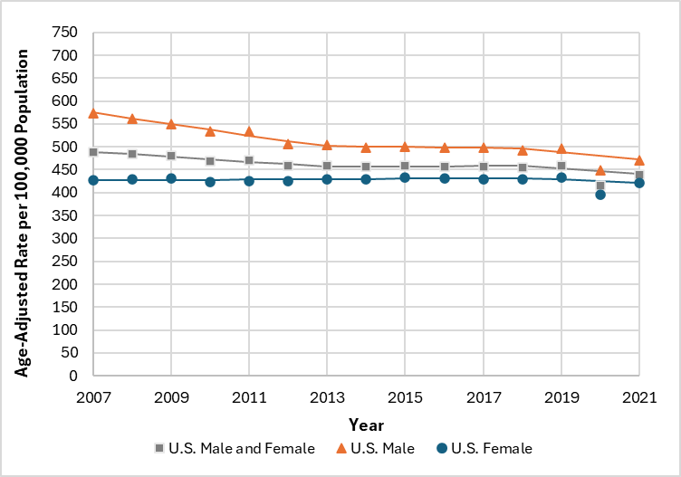

*Source (U.S.):* National Program of Cancer Registries and Surveillance, Epidemiology, and End Results Program SEER*Stat Database: U.S. Cancer Statistics 2001–2021 Public Use Research Database, 2023 submission

Rates are per 100,000 of population age-adjusted to the 2000 U.S. standard population and are calculated using modified U.S. Census populations available from NCI (<https://seer.cancer.gov/popdata/>).

*Incidence rates for year 2020 are plotted but were not used for the analysis of trends since 2020 was an anomaly and would bias estimates.

* Incidence rates for all-site cancer decreased an average of 0.7% per year in the U.S. between 2007 and 2021. There were three distinct trends in the U.S. during this time period:
  + A 1.1% annual decrease between 2007 and 2013.
  + Stable rates between 2013 and 2018.
  + A 1.3% annual decrease between 2018 and 2021.
* Incidence rates for all-site cancer decreased an average of 1.4% per year among U.S. males between 2007 and 2021. There were three distinct trends among U.S. males during this time period:
  + A 2.3% annual decrease between 2007 and 2013.
  + Stable rates between 2013 and 2018.
  + A 1.7% annual decrease between 2018 and 2021.
* The trend in incidence rates for all-site cancer was stable among U.S. females between 2007 and 2021. There were two distinct trends among U.S. females during this time period where there was an increasing trend between 2007 and 2018 and a decreasing trend between 2018 and 2021, but neither were significant.

Trends over Time - Delaware

**Figure 2‑3: Age-Adjusted All-site cancer Incidence Rate Trend by Sex;**

**Delaware, 2007-2021\***

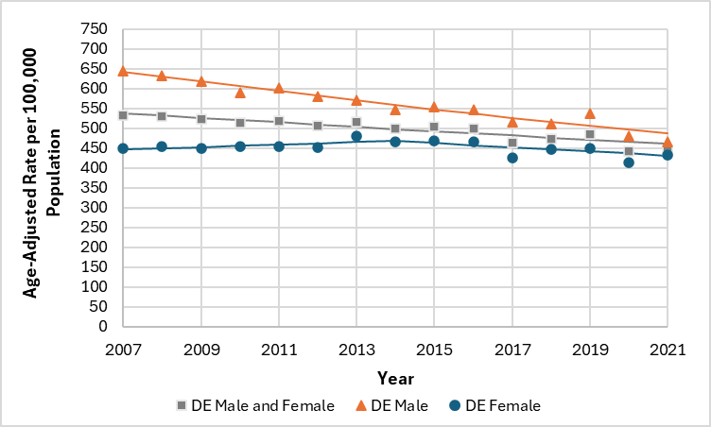

*Source: Delaware Department of Health and Social Services, Division of Public Health, Delaware Cancer Registry, 2024*

Rates are per 100,000 of population using US Census estimates and age-adjusted to the 2000 U.S. standard population

and are calculated using modified U.S. Census populations available from NCI (<https://seer.cancer.gov/popdata/>).

*Incidence rates for year 2020 are plotted but were not used for the analysis of trends since 2020 was an anomaly and

would bias estimates.

* Incidence rates for all-site cancer decreased an average of 1.1% per year in Delaware between 2007 and 2021 and the trend was consistent over this time period.
* Incidence rates for all-site cancer decreased an average of 2.0% per year among Delaware males between 2007 and 2021 and the trend was consistent over this time period.
* The trend in incidence rates for all-site cancer was stable among Delaware females when averaged over the 2007 and 2021 time period. There were two distinct trends among Delaware females during this time period:
  + A 0.7% annual increase between 2007 and 2014.
  + A 1.2% annual decrease between 2014 and 2021.

**Figure 2‑4: Age-Adjusted All-site CANCER INCIDENCE RATE Trend BY RACE/ETHNICITY; Males, Delaware, 2007-2021\***

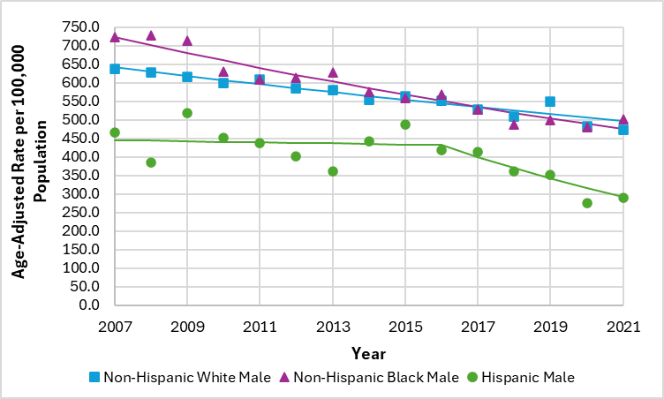

*Source: Delaware Department of Health and Social Services, Division of Public Health, Delaware Cancer Registry, 2024*

Rates are per 100,000 of population using US Census estimates and age-adjusted to the 2000 U.S. standard population

and are calculated using modified U.S. Census populations available from NCI (<https://seer.cancer.gov/popdata/>).

*Incidence rates for year 2020 are plotted but were not used for the analysis of trends since 2020 was an anomaly and

would bias estimates.

* Incidence rates for all-site cancer decreased an average of 1.8% per year among non-Hispanic White males in Delaware between 2007 and 2021 and the trend was consistent over this time period.
* Incidence rates for all-site cancer decreased an average of 3.0% per year among non-Hispanic Black males in Delaware between 2007 and 2021 and the trend was consistent over this time period.
* Incidence rates for all-site cancer decreased an average of 2.9% per year among Hispanic males in Delaware between 2007 and 2021. There were two distinct trends among Hispanic males during this time period:
  + Stable rates between 2007 and 2016.
  + A 7.5% annual decrease between 2016 and 2021.

**Figure 2‑5: Age-Adjusted All-site CANCER INCIDENCE RATE Trend BY RACE/ETHNICITY; feMales, Delaware, 2007-2021\***

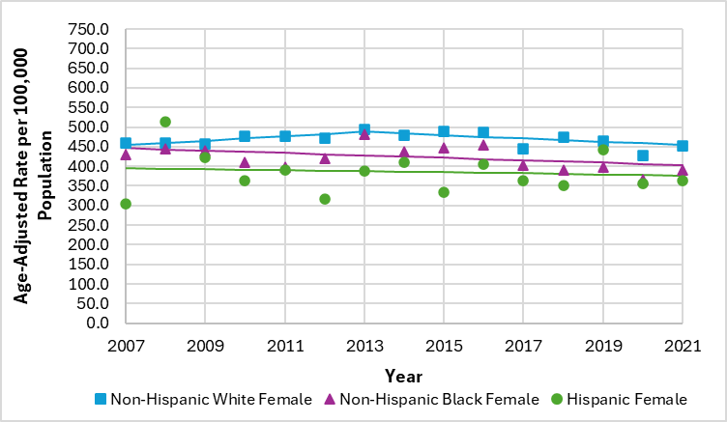

*Source: Delaware Department of Health and Social Services, Division of Public Health, Delaware Cancer Registry, 2024*

Rates are per 100,000 of population using US Census estimates and age-adjusted to the 2000 U.S. standard population

and are calculated using modified U.S. Census populations available from NCI (<https://seer.cancer.gov/popdata/>).

*Incidence rates for year 2020 are plotted but were not used for the analysis of trends since 2020 was an anomaly and

would bias estimates.

* The trend in incidence rates for all-site cancer was stable among non-Hispanic White females in Delaware between 2007 and 2021. There were two distinct trends among non-Hispanic White females in Delaware during this time period:
  + A 1.2% annual increase between 2007 and 2013.
  + A 0.9% annual decrease between 2013 and 2021.
* The trend in incidence rates for all-site cancer was stable among both non-Hispanic Black and Hispanic females in Delaware between 2007 and 2021.

Age-Specific Incidence Rates – Delaware

**Figure 2‑6: Age-Specific All-site cancer Incidence Rates by Sex; Delaware, 2017-2021**

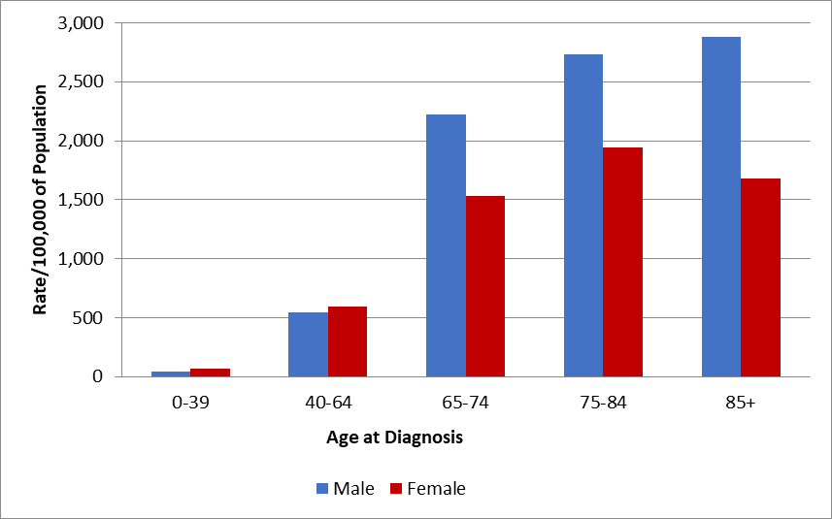

*Source: Delaware Department of Health and Social Services, Division of Public Health, Delaware Cancer Registry, 2024*

Rates are per 100,000 of population age-adjusted to the 2000 U.S. standard population and are calculated using modified U.S. Census populations available from NCI (<https://seer.cancer.gov/popdata/>).

* In 2017-2021 in Delaware, the all-site cancer incidence rate was highest for males 85 years of age and older and for females between 75 and 84 years of age.

**Figure 2‑7: Age-Specific All-site cancer Incidence Rates by Race/ethnicity;**

**Delaware, 2017-2021**

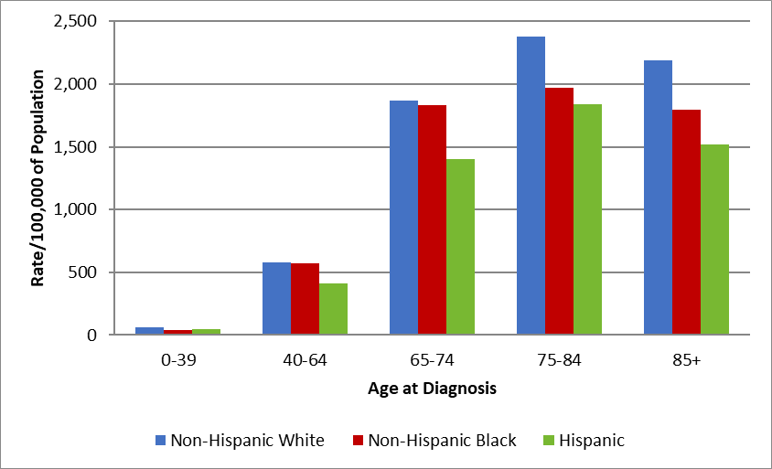

*Source: Delaware Department of Health and Social Services, Division of Public Health, Delaware Cancer Registry, 2024*

Rates are per 100,000 of population age-adjusted to the 2000 U.S. standard population and are calculated using modified U.S. Census populations available from NCI (<https://seer.cancer.gov/popdata/>).

* Delaware’s 2017-2021 all-site cancer incidence rate was highest for non-Hispanic White, non-Hispanic Black, and Hispanic Delawareans between 75 and 84 years of age.

**Table 2‑3: Age-Specific All-site cancer Incidence Rates BY SEX AND RACE/ETHNICITY;**

**Delaware, 2017-2021**

|  |  |  |  |  |  |  |  |  |  |
| --- | --- | --- | --- | --- | --- | --- | --- | --- | --- |
| Age at Diagnosis | Non-Hispanic White | | | Non-Hispanic Black | | | Hispanic | | |
| **All** | **Male** | **Female** | **All** | **Male** | **Female** | **All** | **Male** | **Female** |
| 0-39 | 61.3 | 43.5 | 79.2 | 42.9 | 37.4 | 47.6 | 48.9 | 30.2 | 69.4 |
| 40-64 | 581.8 | 547.4 | 616.4 | 568.0 | 588.2 | 551.9 | 413.3 | 347.9 | 483.5 |
| 65-74 | 1866.3 | 2195.2 | 1572.5 | 1832.9 | 2398.3 | 1407.8 | 1398.9 | 1484.6 | 1317.4 |
| 75-84 | 2374.4 | 2808.7 | 2013.7 | 1968.7 | 2370.7 | 1691.1 | 1838.3 | 1805.7 | 1864.8 |
| 85+ | 2186.8 | 3035.7 | 1703.8 | 1794.3 | 2209.2 | 1599.2 | 1518.1 | 2026.4 | 1115.8 |

*Source: Delaware Department of Health and Social Services, Division of Public Health, Delaware Cancer Registry, 2024*

Rates are per 100,000 of population age-adjusted to the 2000 U.S. standard population and are calculated using modified U.S. Census populations available from NCI (<https://seer.cancer.gov/popdata/>).

* In 2017-2021, the all-site cancer incidence rate was highest for non-Hispanic White and Hispanic males 85 years of age and older and for non-Hispanic Black males between 65 and 74 years of age.
* The 2017-2021 all-site cancer incidence rate was highest for non-Hispanic White, Hispanic, and non-Hispanic Black females between 75 and 84 years.

## Mortality

|  |
| --- |
| For 2017-2021, Delaware ranked 16th in the U.S. for all-site cancer mortality (15th in 2016-2020); males ranked 16th (14th in 2016-2020) and females ranked 22nd (19th in 2016-2020)[12]. |

2017-2021 Data

**Table 2‑4: Number of All-site cancer DEATHS, BY SEX AND RACE/ETHNICITY;**

**Delaware and Counties, 2017-2021**

|  |  |  |  |  |  |  |  |  |  |  |  |  |
| --- | --- | --- | --- | --- | --- | --- | --- | --- | --- | --- | --- | --- |
|  | All Races | | | Non-Hispanic White | | | Non-Hispanic Black | | | Hispanic | | |
|  | **All** | **Male** | **Female** | **All** | **Male** | **Female** | **All** | **Male** | **Female** | **All** | **Male** | **Female** |
| Delaware | 10,453 | 5,562 | 4,891 | 8,144 | 4,411 | 3,733 | 1,883 | 913 | 970 | 234 | 131 | 103 |
| Kent | 1,930 | 1,022 | 908 | 1,436 | 771 | 665 | 399 | 192 | 207 | 49 | 31 | 18 |
| New Castle | 5,361 | 2,780 | 2,581 | 3,838 | 2,030 | 1,808 | 1,261 | 609 | 652 | 149 | 80 | 69 |
| Sussex | 3,162 | 1,760 | 1,402 | 2,870 | 1,610 | 1,260 | 223 | 112 | 111 | 36 | 20 | 16 |

*Source: Delaware Department of Health and Social Services, Division of Public Health, Delaware Health Statistics Center, 2024*

* In Delaware in 2017-2021:
* There were 10,453 deaths from cancer, an average of 2,090 per year.
* Males accounted for 53% of all-site cancer deaths.
* Non-Hispanic White Delawareans accounted for 78% of all-site cancer deaths.

**Table 2‑5: FIVE-YEAR Average Age-Adjusted All-site cancer Mortality**

**Rates Overall and by Sex; U.S., Delaware, and Counties, 2017-2021**

|  |  |  |  |
| --- | --- | --- | --- |
|  | Overall | Male | Female |
| U.S. | 148.4 | 176.5 | 128.3 |
| Delaware | 154.1 | 184.7 | 131.7 |
| Kent | 168.7 | 201.6 | 143.8 |
| New Castle | 154.6 | 185.3 | 133.5 |
| Sussex | 147.0 | 177.3 | 123.6 |

*Source (Delaware): Delaware Department of Health and Social Services, Division of Public Health, Delaware Health Statistics Center, 2024*

*Source (U.S.): Surveillance, Epidemiology, and End Results (SEER) Program, SEER*Stat Database: Mortality - All COD, Aggregated With State, Total U.S. (1990-2022)*

Rates are per 100,000 of population age-adjusted to the 2000 U.S. standard population and are calculated using modified U.S. Census populations available from NCI (<https://seer.cancer.gov/popdata/>).

**Figure 2‑8: FIVE-YEAR Average Age-Adjusted All-site CANCER MORTALITY RATES BY SEX AND RACE/ETHNICITY; U.S. and Delaware, 2017-2021**

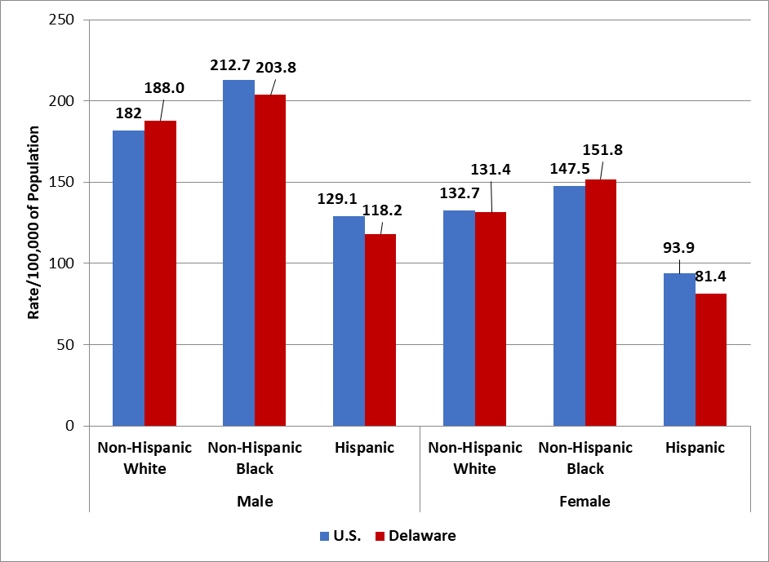

*Source (Delaware): Delaware Department of Health and Social Services, Division of Public Health, Delaware Health Statistics Center, 2024*

*Source (U.S.): Surveillance, Epidemiology, and End Results (SEER)*Stat Database: Mortality - All COD, Aggregated With State, Total U.S. (1990-2022)*

Rates are per 100,000 of population age-adjusted to the 2000 U.S. standard population and are calculated using modified U.S. Census populations available from NCI (<https://seer.cancer.gov/popdata/>).

* In Delaware from 2017-2021:
  + Males (184.7 per 100,000 population) had a statistically significantly higher all-site cancer mortality rate compared to females (131.7 per 100,000 population).
  + Non-Hispanic Black Delawareans (171.4 per 100,000 population) had a statistically significantly higher all compared to non-Hispanic White Delawareans (155.7 per 100,000 population).
  + Hispanic Delawareans (98.6 per 100,000 population) had a statistically significantly lower all-site cancer mortality rate compared to non-Hispanic White Delawareans (155.7 per 100,000 population).
* Comparing Delaware and the U.S. from 2017-2021:
  + Delaware (154.1 per 100,000 population) had a higher all-site cancer mortality rate compared to the U.S. (148.4 per 100,000 population).
  + Delaware males (184.7 per 100,000 population) had a higher all-site cancer mortality rate compared to U.S. males (176.5 per 100,000 population).
  + Delaware females (131.7 per 100,000 population) had a higher all-site cancer mortality rate compared to U.S. females (128.3 per 100,000 population).
  + Non-Hispanic White Delawareans (155.7 per 100,000 population) had a higher all-site cancer mortality rate compared to non-Hispanic White Americans in the U.S. (153.6 per 100,000 population).
  + Non-Hispanic Black Delawareans (171.4 per 100,000 population) had a higher all-site cancer mortality rate compared to non-Hispanic White Americans in the U.S. (172.0 per 100,000 population).
  + Hispanic Delawareans (98.6 per 100,000 population) had a lower all-site cancer mortality rate compared to Hispanic Americans in the U.S. (108.1 per 100,000 population).

Trends over Time - U.S.

**Figure 2‑9: Age-Adjusted All-site cancer Mortality Rate Trend by Sex;**

**U.S., 2007-2021**

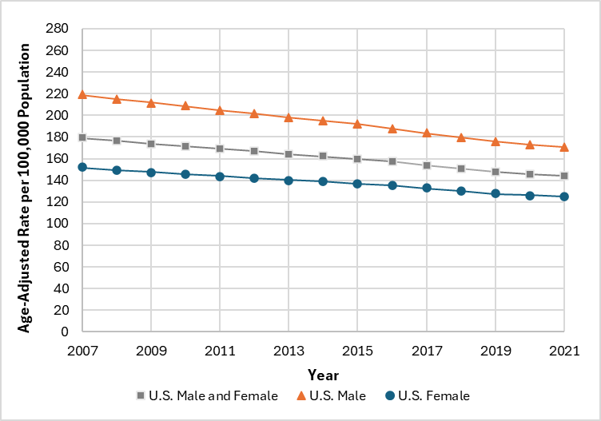

*Source (U.S.): Surveillance, Epidemiology, and End Results (SEER) Program (www.seer.cancer.gov) SEER*Stat Database: Mortality - All COD, Aggregated With State, Total U.S. (1990-2022)*

Rates are per 100,000 of population age-adjusted to the 2000 U.S. standard population and are calculated using modified U.S. Census populations available from NCI (<https://seer.cancer.gov/popdata/>).

* Mortality rates for all-site cancer decreased an average of 1.5% per year in the U.S. between 2007 and 2021. There were three distinct trends in the U.S. during this time period, where there was an annual decrease of:
  + 1.4% between 2007 and 2016.
  + 2.1% between 2016 and 2019.
  + 1.2% between 2019 and 2021.
* Mortality rates for all-site cancer decreased an average of 1.8% per year among U.S. males between 2007 and 2021. There were three distinct trends among U.S. males during this time period, where there was an annual decrease of:
  + 1.6% between 2007 and 2015.
  + 2.2% between 2015 and 2019.
  + 1.5% between 2019 and 2021.
* Mortality rates for all-site cancer decreased an average of 1.4% per year among U.S. females between 2007 and 2021. There were three distinct trends among U.S. females during this time period, where there was an annual decrease of:
  + 1.2% between 2007 and 2016.
  + 2.0% between 2016 and 2019.
  + 1.1% between 2019 and 2021.

Trends over Time - Delaware

**Figure 2‑10: Age-Adjusted All-site CANCER MORTALITY RATE Trend**

**BY SEX; Delaware, 2007-2021**

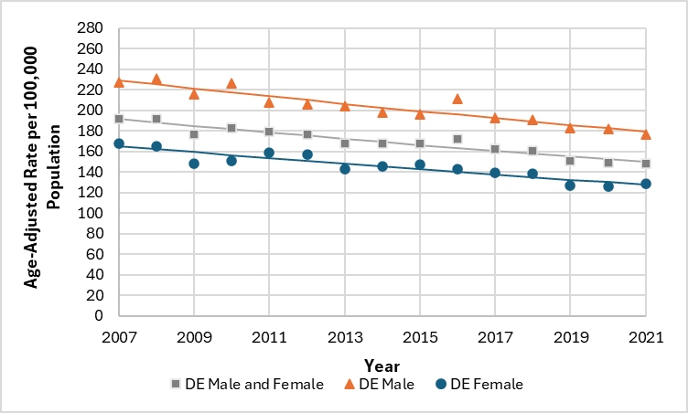

*Source (Delaware): Delaware Department of Health and Social Services, Division of Public Health, Delaware Health Statistics Center, 2024*

Rates are per 100,000 of population age-adjusted to the 2000 U.S. standard population and are calculated using modified U.S. Census populations available from NCI (<https://seer.cancer.gov/popdata/>).

* Mortality rates for all-site cancer decreased an average of 1.8% per year in Delaware between 2007 and 2021 and the trend was consistent over this time period.
* Mortality rates for all-site cancer decreased an average of 1.7% per year among Delaware males between 2007 and 2021 and the trend was consistent over this time period.
* Mortality rates for all-site cancer decreased an average of 1.8% per year among Delaware females between 2007 and 2021 and the trend was consistent over this time period.

**Figure 2‑11: Age-Adjusted All-site CANCER MORTALITY RATE Trend**

**BY Race/ethnicity; males, Delaware, 2007-2021**

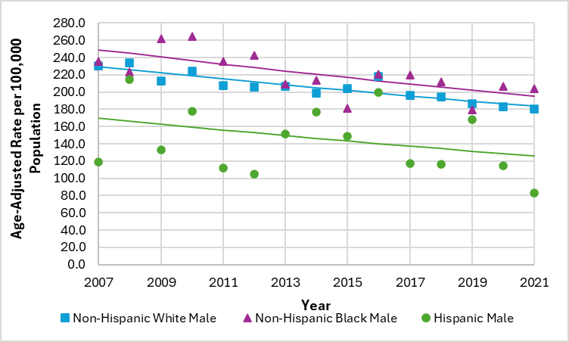

*Source (Delaware): Delaware Department of Health and Social Services, Division of Public Health, Delaware Health Statistics Center, 2024*

Rates are per 100,000 of population age-adjusted to the 2000 U.S. standard population and are calculated using modified U.S. Census populations available from NCI (<https://seer.cancer.gov/popdata/>).

* Mortality rates for all-site cancer decreased an average of 1.6% per year among non-Hispanic White males in Delaware between 2007 and 2021 and the trend was consistent over this time period.
* Mortality rates for all-site cancer decreased an average of 1.7% per year among non-Hispanic Black males in Delaware between 2007 and 2021 and the trend was consistent over this time period.
* The trend in mortality rates for all-site cancer was stable among Hispanic males in Delaware between 2007 and 2021.

**Figure 2‑12: Age-Adjusted All-site CANCER MORTALITY RATE Trend**

**BY Race/ethnicity; FEmales, Delaware, 2007-2021**

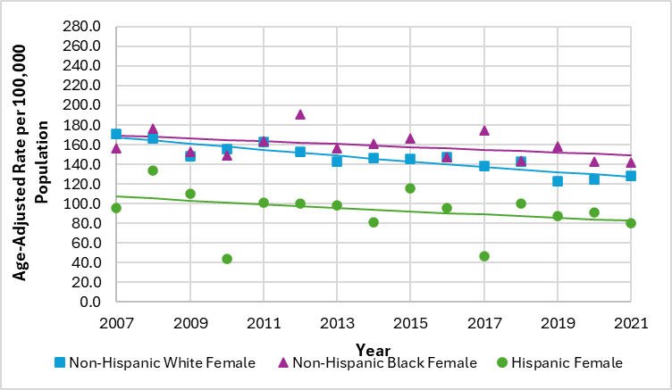

*Source (Delaware): Delaware Department of Health and Social Services, Division of Public Health, Delaware Health Statistics Center, 2024*

Rates are per 100,000 of population age-adjusted to the 2000 U.S. standard population and are calculated using modified U.S. Census populations available from NCI (<https://seer.cancer.gov/popdata/>).

* Mortality rates for all-site cancer decreased an average of 2.0% per year among non-Hispanic White females in Delaware between 2007 and 2021 and the trend was consistent over this time period.
* The trend in mortality rates for all-site cancer was stable among both non-Hispanic Black and Hispanic females in Delaware between 2007 and 2021.

Age-Specific Mortality Rates – Delaware

**Figure 2‑13: Age-Specific All-site cancer Mortality Rates by Sex;**

**Delaware, 2017-2021**

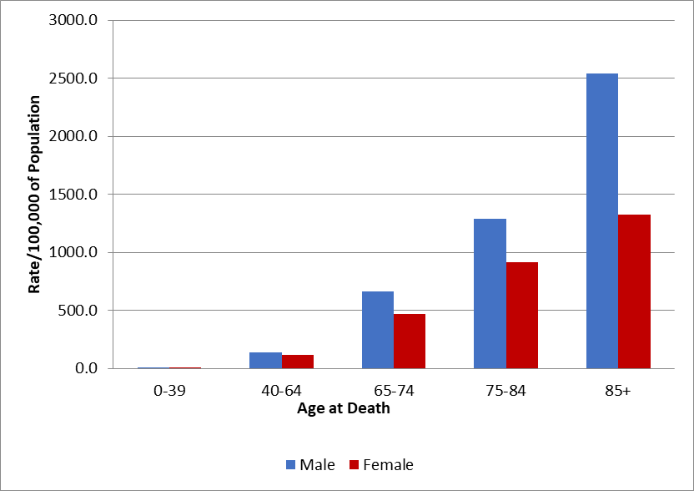

*Source: Delaware Department of Health and Social Services, Division of Public Health, Delaware*

*Health Statistics Center, 2024*

Rates are per 100,000 of population age-adjusted to the 2000 U.S. standard population and are

calculated using modified U.S. Census populations available from NCI (<https://seer.cancer.gov/popdata/>).

* In 2017-2021, Delaware’s all-site mortality rate was highest for both males and females 85 years of age and older.

**Figure 2‑14: Age-Specific All-site cancer Mortality Rates by**

**RACE/Ethnicity; Delaware, 2017-2021**

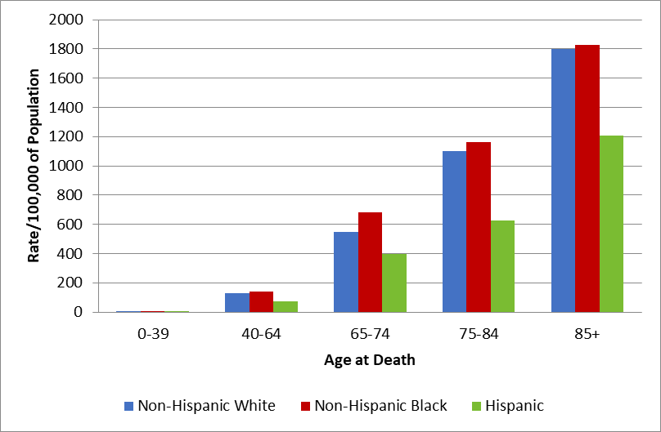

*Source: Delaware Department of Health and Social Services, Division of Public Health, Delaware Health Statistics Center, 2024*

Rates are per 100,000 of population age-adjusted to the 2000 U.S. standard population and are calculated using modified U.S. Census populations available from NCI (<https://seer.cancer.gov/popdata/>).

* Delaware’s 2017-2021 all-site mortality rate was highest for non-Hispanic White, non-Hispanic Black, and Hispanic Delawareans 85 years of age and older.

**Table 2‑6: Age-Specific All-site cancer Mortality Rates BY SEX AND RACE/ETHNICITY;**

**Delaware, 2017-2021**

|  |  |  |  |  |  |  |
| --- | --- | --- | --- | --- | --- | --- |
| Age at Death | Males | | | Females | | |
| **Non-Hispanic White** | **Non-Hispanic Black** | **Hispanic** | **Non-Hispanic White** | **Non-Hispanic Black** | **Hispanic** |
| 0-39 | 4.8 | --- | --- | 5.3 | 5.7 | --- |
| 40-64 | 142.7 | 134.2 | 82.8 | 117.8 | 146.3 | 65.0 |
| 65-74 | 642.7 | 843.4 | 527.3 | 462.3 | 562.9 | 276.5 |
| 75-84 | 1315.3 | 1407.6 | 810.7 | 922.1 | 996.4 | 475.8 |
| 85+ | 2610.8 | 2666.3 | --- | 1337.3 | 1432.2 | 1115.8 |

*Source: Delaware Department of Health and Social Services, Division of Public Health, Delaware Health Statistics Center, 2023*

Rates are per 100,000 of population age-adjusted to the 2000 U.S. standard population and are calculated using modified U.S. Census populations available from NCI (<https://seer.cancer.gov/popdata/>).

---Rates based on fewer than 16 deaths are not individually calculated.

In Delaware from 2017-2021:

* The all-site mortality rate was highest for non-Hispanic White and non-Hispanic Black males 85 years of age and older.
* The all-site mortality rate was highest for non-Hispanic White, non-Hispanic Black, and Hispanic females 85 years of age and older.
* Due to small numbers, mortality rates could not be calculated for certain groups.

# Chapter 3: Site-Specific Cancer

## Incidence

**Figure 3‑1: Percent distribution of cancer cases by cancer site, Delaware, 2017-2021**

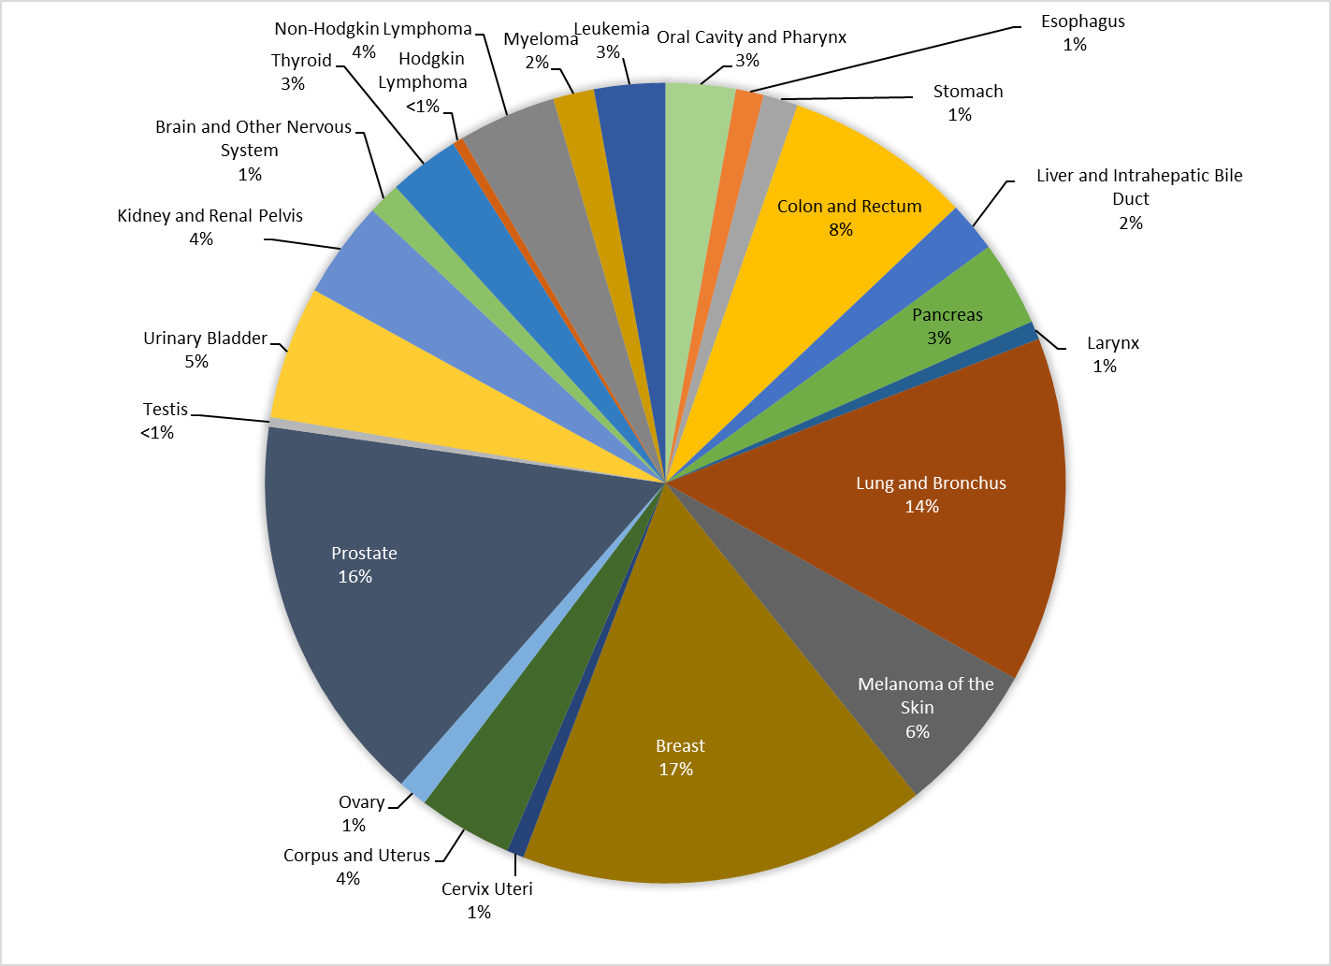

*Source: Delaware Department of Social Services, Division of Public Health, Delaware Cancer Registry, 2024*

* In 2017-2021 in Delaware:
* There were 30,849 new all-site cancer cases diagnosed, an average of 6,169 per year.
* Female breast cancer accounted for 17% of all new cancer cases.
* Lung and bronchus cancer accounted for 14% of all new cancer cases.
* Prostate cancer accounted for 16% of all new cancer cases.
* Colon and rectum (colorectal) cancer accounted for 8% of all new cancer cases.

**TABLE 3‑1: FIVE-YEAR AVERAGE AGE-ADJUSTED CANCER INCIDENCE* RATES BY SEX AND CANCER SITE WITH CONFIDENCE INTERVALS; DELAWARE, 2017-2021**



*Source: Delaware Department of Social Services, Division of Public Health, Delaware Cancer Registry, 2024*

Rates are per 100,000 population and are age-adjusted to the 2000 U.S. standard population (19 age groups – Census P25–1130) and are calculated using modified U.S. Census populations available from NCI (<https://seer.cancer.gov/popdata/>).

*Statistically significantly different from the reference group “Male”. Rate Ratios with p-values were modeled using SEER*Stat 8.4.3 as confirmatory test. “CI” stands for Confidence Interval.

Statistical Differences - Sex

* Comparing Delaware females to Delaware males from 2017 to 2021 in Table 3-1:
* The age-adjusted cancer incidence rate for thyroid cancer among Delaware females (22.8 cases per 100,000 population) was statistically significantly higher compared to Delaware males (7.8 cases per 100,000 population).
* Delaware females had a statistically significantly lower age-adjusted incidence rate compared to Delaware males for the following cancers: all-sites, colon and rectum (colorectal), esophagus, kidney and renal pelvis, larynx, leukemia, liver and intrahepatic bile duct, lung and bronchus, melanoma, myeloma, non-Hodgkin lymphoma, oral cavity and pharynx, pancreas, stomach, and urinary bladder.
  + Example statement: *From 2017-2021,* *the age-adjusted incidence rate for stomach cancer among Delaware females (4.2 cases per 100,000 population) was statistically significantly lower compared to Delaware males (8.5 cases per 100,000 population).*
* There was statistically no difference in the age-adjusted incidence rate among Delaware females compared to Delaware males for brain and other nervous system and Hodgkin lymphoma cancers.
  + Example statement: *From 2017-2021, there was no statistical difference in the age-adjusted cancer incidence rates for Hodgkin lymphoma among Delaware females (2.3 cases per 100,000 population) and Delaware males (2.6 cases per 100,000 population).*

**Table 3-2: FIVE-YEAR Average Age-Adjusted cancer Incidence Rates by Race/Ethnicity and Cancer Site with Confidence INTERVALS; Delaware, 2017-2021**



*Source: Delaware Department of Social Services, Division of Public Health, Delaware Cancer Registry, 2024*

Rates are per 100,000 population and are age-adjusted to the 2000 U.S. standard population (19 age groups – Census P25–1130) and are calculate using modified U.S. Census populations available from NCI (<https://seer.cancer.gov/popdata/>).

*Statistically significantly different from the reference group “non-Hispanic White”. Rate Ratios with p-values were modeled using SEER*Stat 8.4.3 as confirmatory test. “CI” stands for Confidence Interval.

---Rates based on fewer than 16 cases are not individually calculated.

**Table 3-2: FIVE-YEAR Average Age-Adjusted cancer IncidencE Rates by Race/Ethnicity and Cancer Site with Confidence INTERVALS; Delaware, 2017-2021 (CONTINUED)**



*Source: Delaware Department of Social Services, Division of Public Health, Delaware Cancer Registry, 2024*

Rates are per 100,000 population and are age-adjusted to the 2000 U.S. standard population (19 age groups – Census P25–1130) and are calculate using modified U.S. Census populations available from NCI (<https://seer.cancer.gov/popdata/>).

*Statistically significantly different from the reference group “non-Hispanic White.” Rate Ratios with p-values were modeled using SEER*Stat 8.4.3 as confirmatory test. “CI” stands for Confidence Interval.

---Rates based on fewer than 16 cases are not individually calculated.

Statistical Differences – Race/Ethnicity

* Comparing non-Hispanic Black Delawareans to non-Hispanic White Delawareans from 2017-2021:
* Non-Hispanic Black Delawareans had a statistically significantly higher age-adjusted incidence rate compared to non-Hispanic White Delawareans for the following cancers: stomach, liver and intrahepatic bile duct, pancreas, myeloma, and prostate cancers.
* Example statement: *From 2017-2021, the age-adjusted incidence rate for pancreatic cancer among non-Hispanic Black Delawareans (17.5 cases per 100,000 population) was statistically significantly higher compared to non-Hispanic White Delawareans (13.8 cases per 100,000 population).*
* Non-Hispanic Black Delawareans had a statistically significantly lower age-adjusted incidence rate compared to non-Hispanic White Delawareans for oral cavity and pharynx, esophagus, lung and bronchus, urinary bladder, brain and other nervous system, thyroid, non-Hodgkin lymphoma, leukemia, and ovarian cancers.
* *Example statement: From 2017-2021, the age-adjusted cancer incidence rate for leukemia among non-Hispanic Black Delawareans (9.6 cases per 100,000 population) was statistically significantly lower compared to non-Hispanic White Delawareans (13.5 cases per 100,000 population).*
* Non-Hispanic Black Delawareans had statistically no difference in age-adjusted incidence rates compared to non-Hispanic White Delawareans for all-sites, colon and rectum (colorectal), larynx, kidney and renal pelvis, Hodgkin lymphoma, female breast, cervical, and uterine cancers.
* *Example statement: From 2017-2021, there was no statistical difference in the age-adjusted incidence rates for cervical cancer among non-Hispanic Black Delawareans (5.9 cases per 100,000 population) and non-Hispanic White Delawareans (7.4 cases per 100,000 population).*
* Due to fewer than 16 cases, significance testing could not be completed for melanoma and testicular cancers.
* Comparing Hispanic Delawareans to non-Hispanic White Delawareans from 2017-2021:
* Hispanic Delawareans had a statistically significantly higher age-adjusted incidence rate compared to non-Hispanic White Delawareans for stomach, and liver and intrahepatic bile duct cancers.
* *Example statement: From 2017-2021, the age-adjusted incidence rate for stomach cancer among Hispanic Delawareans (11.4 cases per 100,000 population) was statistically significantly higher compared to non-Hispanic White Delawareans (5.3 cases per 100,000 population).*
* Hispanic Delawareans had a statistically significantly lower age-adjusted incidence rate compared to non-Hispanic White Delawareans for all-sites, oral cavity and pharynx, colon and rectum (colorectal), lung and bronchus, urinary bladder, prostate, and female breast cancers.
* *Example statement: From 2017-2021, the age-adjusted incidence rate for urinary bladder cancers among Hispanic Delawareans (16.1 cases per 100,000 population) was statistically significantly lower compared to non-Hispanic White Delawareans (24.5 cases per 100,000 population).*
* Hispanic Delawareans had statistically no difference in age-adjusted incidence rates compared to non-Hispanic White Delawareans for pancreas, kidney and renal pelvis, non-Hodgkin lymphoma, brain and other nervous system, myeloma, leukemia, uterine, and ovarian cancers.
* *Example statement: From 2017-2021, there was no statistical difference in the age-adjusted incidence rates for thyroid cancer among Hispanic Delawareans (12.8 cases per 100,000 population) and non-Hispanic White Delawareans (16.5 cases per 100,000 population).*
* Due to fewer than 16 cases, significance testing could not be completed for cervix, esophagus, Hodgkin lymphoma, larynx, melanoma, and testicular cancers.

## Mortality

**Figure 3‑2: Percent distribution of cancer deaths by cancer site, Delaware, 2017-2021**

*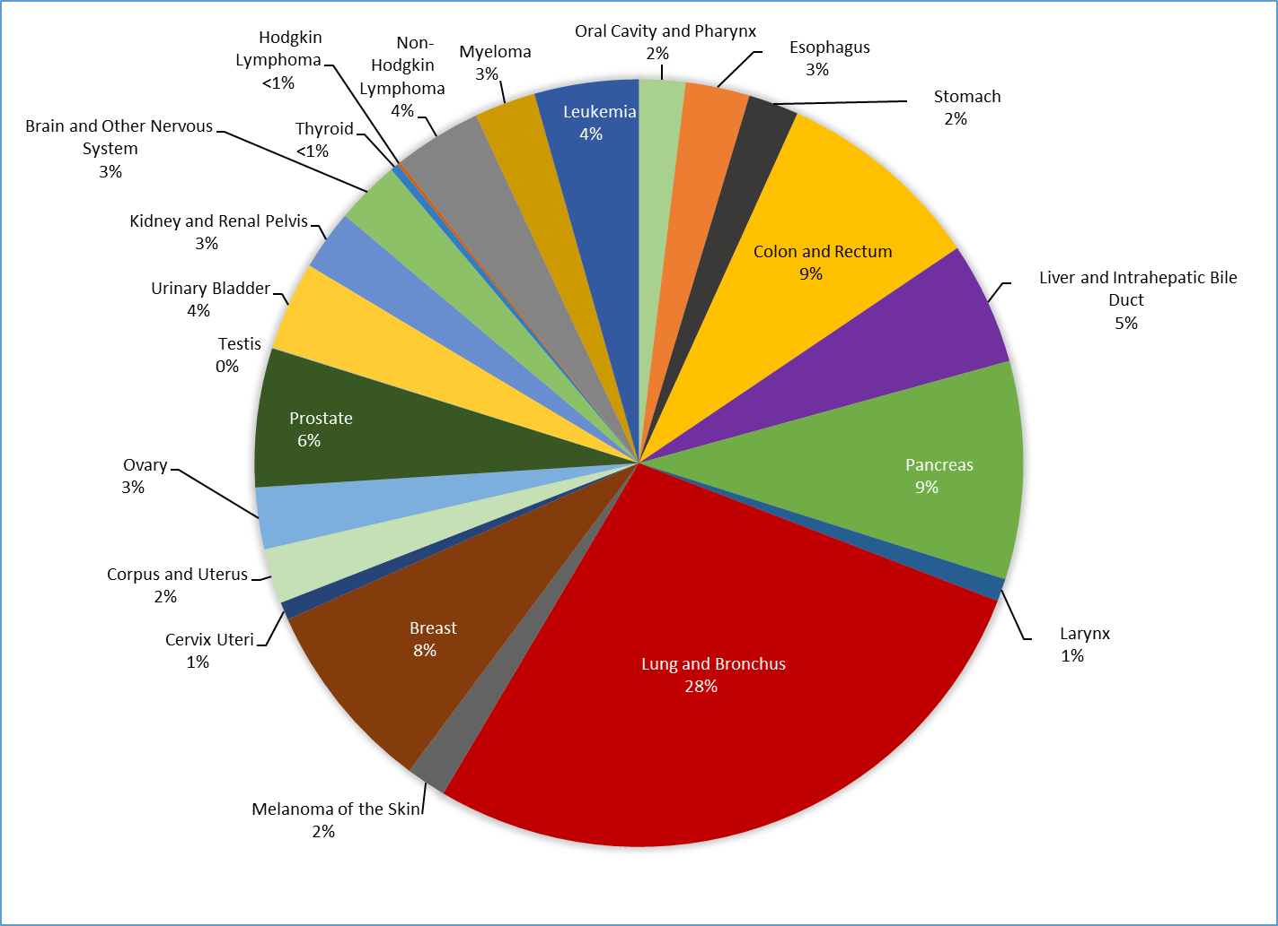Source: Delaware Department of Health and Social Services, Division of Public Health, Delaware Health Statistics Center, 2023*

* In 2017-2021 in Delaware:
* There were 10,453 deaths from cancer, an average of 2,090 per year.
* Lung and bronchus cancer accounted for 28% of all new cancer deaths.
* Colon and rectum (colorectal) cancer accounted for 9% of all new cancer deaths.
* Pancreas (pancreatic) cancer accounted for 9% of all new cancer deaths.
* Female breast cancer accounted for 8% of all new cancer deaths.
* Prostate cancer accounted for 6% of all new cancer deaths.

**Table 3‑3: FIVE-YEAR Average Age-Adjusted cancer Mortality Rates by Sex and Cancer Site with Confidence INTERVALS; Delaware, 2017-2021**



*Source: Delaware Department of Social Services, Division of Public Health, Delaware Cancer Registry, 2024*

Rates are per 100,000 population and are age-adjusted to the 2000 U.S. standard population (19 age groups – Census P25–1130) and are calculate using modified U.S. Census populations available from NCI (<https://seer.cancer.gov/popdata/>).

*Statistically significantly different from the reference group “Male”. Rate Ratios with p-values were modeled using SEER*Stat 8.4.3 as confirmatory test. “CI” stands for Confidence Interval.

---Rates based on fewer than 16 deaths are not individually calculated.

Statistical Differences - Sex

* Comparing Delaware females to Delaware males from 2017-2021 in Table 3-3:
* Delaware females had a statistically significantly lower age-adjusted mortality rate compared to Delaware males for the following cancers: all-sites, brain and other nervous system, colon and rectum (colorectal), esophagus, kidney and renal pelvis, larynx, leukemia, liver and intrahepatic bile duct, lung and bronchus, melanoma, myeloma, non-Hodgkin lymphoma, oral cavity and pharynx, pancreas, stomach, and urinary bladder.
  + Example statement: *From 2017-2021, the age-adjusted mortality rate for lung and bronchus cancer among Delaware females (30.9 deaths per 100,000 population) was statistically significantly lower compared to Delaware males (43.7 deaths per 100,000 population).*
* Due to fewer than 16 deaths, significance testing could not be completed for thyroid and Hodgkin lymphoma cancers.

**Table 3-4: FIVE-YEAR Average Age-Adjusted cancer Mortality Rates by Race/Ethnicity and Cancer Site with Confidence INTERVALS; Delaware, 2017-2021**



*Source: Delaware Department of Social Services, Division of Public Health, Delaware Cancer Registry, 2024*

Rates are per 100,000 population and are age-adjusted to the 2000 U.S. standard population (19 age groups – Census P25–1130) and are calculate using modified U.S. Census populations available from NCI (<https://seer.cancer.gov/popdata/>).

*Statistically significantly different from the reference group “non-Hispanic White”. Rate Ratios with p-values were modeled using SEER*Stat 8.4.3 as confirmatory test. “CI” stands for Confidence Interval.

---Rates based on fewer than 16 deaths are not individually calculated.

**Table 3-4: FIVE-YEAR Average Age-Adjusted cancer Mortality Rates by Race/Ethnicity and Cancer Site with Confidence INTERVALS; Delaware, 2017-2021 (CONTINUED)**



*Source: Delaware Department of Social Services, Division of Public Health, Delaware Cancer Registry, 2024*

Rates are per 100,000 population and are age-adjusted to the 2000 U.S. standard population (19 age groups – Census P25–1130) and are calculate using modified U.S. Census populations available from NCI (<https://seer.cancer.gov/popdata/>).

*Statistically significantly different from the reference group “non-Hispanic White”. Rate Ratios with p-values were modeled using SEER*Stat 8.4.3 as confirmatory test. “CI” stands for Confidence Interval.

---Rates based on fewer than 16 deaths are not individually calculated.

Statistical Differences – Race/Ethnicity

* Comparing non-Hispanic Black Delawareans to non-Hispanic White Delawareans from 2017-2021:
* Non-Hispanic Black Delawareans had a statistically significantly higher age-adjusted mortality rate compared to non-Hispanic White Delawareans for the following cancers: all-sites, stomach, larynx, liver and intrahepatic bile duct, pancreas, myeloma, female breast, prostate, and uterine cancers.
* Example statement: *From 2017-2021, the age-adjusted mortality rate for prostate cancer among non-Hispanic Black Delawareans (33.6 deaths per 100,000 population) was statistically significantly higher compared to non-Hispanic White Delawareans (17.4 deaths per 100,000 population).*
* Non-Hispanic Black Delawareans had a statistically significantly lower age-adjusted mortality rate compared to non-Hispanic White Delawareans for brain and other nervous system and esophagus cancers.
* *Example statement: From 2017-2021, the age-adjusted mortality rate for brain and other nervous system cancers among non-Hispanic Black Delawareans (2.4 deaths per 100,000 population) was statistically significantly lower compared to non-Hispanic White Delawareans (4.5 deaths per 100,000 population).*
* Non-Hispanic Black Delawareans had statistically no difference in age-adjusted mortality rates compared to non-Hispanic White Delawareans for oral cavity and pharynx, colon and rectum (colorectal), lung and bronchus, urinary bladder, kidney and renal pelvis, non-Hodgkin lymphoma, leukemia, cervical, and ovarian cancers.
* *Example statement: From 2017-2021, there was no statistical difference in the age-adjusted mortality rates for colon and rectum (colorectal) cancer among non-Hispanic Black Delawareans (13.9 deaths per 100,000 population) and non-Hispanic White Delawareans (12.6 deaths per 100,000 population).*
* Due to fewer than 16 deaths, significance testing could not be completed for melanoma, thyroid, Hodgkin lymphoma, and testicular cancers.
* Comparing Hispanic Delawareans to non-Hispanic White Delawareans from 2017-2021:
* The age-adjusted mortality rate for stomach cancer among Hispanic Delawareans (9.9 deaths per 100,000 population) was statistically significantly higher compared to non-Hispanic White Delawareans (2.3 deaths per 100,000 population).
* Hispanic Delawareans had a statistically significantly lower age-adjusted mortality rate compared to non-Hispanic White Delawareans for all-sites, lung and bronchus, and female breast cancers.
* *Example statement: From 2017-2021, the age-adjusted mortality rate for lung and bronchus cancers among Hispanic Delawareans (16.5 deaths per 100,000 population) was statistically significantly lower compared to non-Hispanic White Delawareans (38.3 deaths per 100,000 population).*
* Hispanic Delawareans had statistically no difference in age-adjusted mortality rates compared to non-Hispanic White Delawareans for colon and rectum (colorectal), liver and intrahepatic bile duct, and non-Hodgkin lymphoma cancers.
* *Example statement: From 2017-2021, there was no statistical difference in the age-adjusted mortality rates for colon and rectum (colorectal) cancer among Hispanic Delawareans (8.5 deaths per 100,000 population) and non-Hispanic White Delawareans (12.6 deaths per 100,000 population).*
* Due to fewer than 16 deaths, significance testing could not be completed for brain and other nervous system, cervix, esophagus, Hodgkin lymphoma, kidney and renal pelvis, larynx, leukemia, melanoma, myeloma, ovary, oral cavity and pharynx, pancreas, prostate, testis, thyroid, uterine, and urinary bladder cancers.

# Data Sources and Methodology

## Cancer Incidence Data

### **Delaware Cancer Registry**

This report covers data on cancer cases diagnosed among Delawareans from January 1, 2017 to December 31, 2021, that were reported to the Delaware Cancer Registry (DCR) by November 2023. Trends in incidence rates are based on cancers diagnosed from January 1, 2007 to December 31, 2021. The COVID-19 pandemic resulted in delays and reductions in cancer screening and diagnosis, which subsequently led to a decline in 2020 incidence counts and rates. For this reason, researchers consider 2020 an anomaly. Inclusion of 2020 rates would bias the estimates of trends over time and therefore, 2020 rates were not included in trend analysis.[13]

During 2017-2021, there were 30,849 cancer cases diagnosed among Delawareans, which includes individuals with cancers diagnosed at more than one site (known as multiple primaries). With the exception of urinary bladder cancer, only malignant tumors are included in the analyses. *In situ* urinary bladder cancer cases are included because, based on language used by pathologists, it is difficult to distinguish them from malignant cancers.

The International Classification of Diseases for Oncology, Second Edition (ICD-O-2), describes the topography (primary anatomic site) and morphology (histology) for cancers reported from 1988 through 2000. Cancers diagnosed from 2001 through the present are coded using the International Classification of Diseases for Oncology, Third Edition (ICD-O-3)[14]. Relevant codes for this report are in Appendix B. The topography code defines both the site of the tumor and the type of cancer. The first four digits of the morphology code define the histology of the cancer and the fifth digit indicates whether the cancer is malignant, benign, *in situ*, or uncertain. Consistent with the CDC’s publication of the *U.S. Cancer Statistics*, Kaposi’s sarcoma and mesothelioma are considered separate sites based on distinct histology codes.

### **United States Cancer Statistics (USCS)**

U.S. incidence data were obtained from United States Cancer Statistics (USCS) which consists of data from cancer registries participating in the Centers for Disease Control and Prevention’s (CDC’s) National Program of Cancer Registries (NPCR) and the National Cancer Institute’s (NCI) Surveillance, Epidemiology, and End Results (SEER) Program. Incidence data are included from selected cancer registries meeting U.S. Cancer Statistics data quality criteria covering 99% of the U.S. population.

Historically, Delaware’s cancer incidence rates were compared to cancer incidence rates calculated using data from the SEER program, which began in 1973 with data collected from nine SEER program cancer registries (SEER-9). Over time, the number of SEER program registries expanded. In 2009, the Delaware Department of Health and Social Services (DHSS), Division of Public Health (DPH) and the Delaware Cancer Consortium (DCC) began using cancer incidence rates based on 18 population-based registries as a comparison for Delaware’s cancer incidence rates. Starting with the *Cancer Incidence and Mortality in Delaware, 2015-2019* report, USCS data was used to align with national statistics presented by national standard-setters that includes the most comprehensive data covering a majority of the U.S. population.

## Cancer Mortality Data

### **Delaware Health Statistics Center**

Mortality data are provided by the Delaware Health Statistics Center (DHSC) for all death certificates filed in Delaware from 2007 through 2021. Trend analyses for cancer mortality are based on deaths that occurred from January 1, 2007 to December 31, 2021.

For deaths that occurred from 1999 to the present, the International Classification of Diseases, Tenth Edition (ICD-10) is used to code cause of death. To determine the underlying cause of death, the sequence of events leading to the individual’s death are recorded on the death certificate and run through the Automated Classification of Medical Entities (ACME) software used by the National Center for Health Statistics (NCHS). This program uses a series of rules and hierarchies of events to select the most appropriate underlying cause of death.

### **National Center for Health Statistics**

U.S. mortality data were obtained from the NCHS. U.S. mortality data are compiled from all death certificates filed in the 50 states and the District of Columbia from 1980 through 2022. Cause of death was coded by NCHS in accordance with World Health Organization regulations that stipulate that cancer deaths be coded using the most current revision of the International Classification of Diseases. As in Delaware, deaths that occurred prior to 1999 in the U.S. are coded using ICD-9 and beginning with 1999 deaths are coded using ICD-10. These U.S. mortality data were accessed through SEER*Stat[15].

## Population Estimates, 2017-2021

Cancer incidence and mortality rates for the U.S. are calculated using population totals estimated by the U.S. Census. Delaware rates are based on population estimates released by the U.S. Census Bureau. Population files are obtained from the NCI SEER website.[16] When calculating age-adjusted mortality rates, the CDC utilizes SEER population estimates derived from the U.S. Census for the denominator[17]. To remain consistent with national reporting of cancer statistics, DPH utilizes U.S. Census data from SEER.[18]

## Risk Factors and Early Detection

The Behavioral Risk Factor Survey (BRFS) is the world’s largest ongoing telephone health survey tracking health conditions and risk behaviors in the United States yearly since 1984. Currently, data are collected in all 50 states and four territories. The survey was developed to monitor the statewide prevalence of behavioral risk factors influencing premature morbidity and mortality. The BRFS includes a core set of questions developed by the CDC and is administered to adults 18 years of age and older. Delaware’s BRFS is a collaborative effort between DPH and the CDC. BRFS questions target lifestyle behaviors (including tobacco use, fruit and vegetable consumption, exercise, and weight control); cancer screening practices; health status; and health care access and use[19]. Technological and cultural changes are posing challenges to survey research. One of the most significant challenges is the rapid increase in households where telephone service is provided primarily, or only, via cell phone service. These "cell phone" households are, at least currently, more common among young adults and minority populations.[20]

Originally, the BRFS survey was administered by a random-digit-dial telephone survey. Starting with reporting 2011 data, the BRFS became a "multi-mode survey," using several modes of data collection — including landline telephone interviews, cell phone interviews, and online follow-up surveys for some respondents who did not want to respond by phone. Also, the BRFS uses a new method for weighting data, called “raking,” which more accurately reflects the actual population of each state.[21] Because cell phones are quickly replacing landline phones, it was difficult to obtain a true representative sample of some population subgroups during the late 2000s. The response rate problems likely resulted in less accurate prevalence estimates for some behaviors or conditions more prevalent in populations who primarily used cell phones. For example, the prevalence of cigarette smoking, known to be more prevalent among young adults, may have been under-estimated for several years.[22]

The data in Appendix D and E relate to cancer screening and risk factor prevalence among Delawareans. Data on breast, cervical, colorectal, and prostate cancer screening patterns among Delawareans are provided in relevant cancer site chapters earlier in this document. Data on overweight and obesity, physical activity, and consumption of dietary fruits and vegetables are provided in Appendix E.[23] Data on known and suspected cancer risk factors and screening recommendations are in Appendices D and E. The 2022 BRFS data include screening compliance data (Appendix D) and risk factor data (Appendix E).

## Statistical Methodology and Technical Terms

### **Age-Adjustment of Incidence and Mortality Rates**

The age distribution of a population is an important determinant of the burden of cancer. Because cancer incidence and mortality increase with age, crude rates cannot be used for comparisons of cancer statistics between sexes, racial or ethnic groups, or geographic entities across different time spans.

Age adjustment is useful when comparing two or more populations with different age distributions at one point in time or one population at two or more points in time.[24] To calculate an age-adjusted incidence rate, the crude incidence rate for each of 18 five-year age groups is multiplied by a fixed population weight for that specific age group using the appropriate 2000 U.S. Standard Population (Table A-1).[25] Individual age-specific rates are then summed to obtain the overall age-adjusted rate.

**TABLE A‑1: U.S. STANDARD YEAR 2000 POPULATION WEIGHTS, BY AGE GROUP**

|  |  |  |  |
| --- | --- | --- | --- |
| Age Group | Population Weight | Age Group | Population Weight |
| 0-4 | 0.0691 | **45-49** | 0.0721 |
| 5-9 | 0.0725 | **50-54** | 0.0627 |
| 10-14 | 0.0730 | **55-59** | 0.0485 |
| 15-19 | 0.0722 | **60-64** | 0.0388 |
| 20-24 | 0.0665 | **65-69** | 0.0343 |
| 25-29 | 0.0645 | **70-74** | 0.0318 |
| 30-34 | 0.0710 | **75-79** | 0.0270 |
| 35-39 | 0.0808 | **80-84** | 0.0178 |
| 40-44 | 0.0819 | **85+** | 0.0155 |

*Source: U.S. Census 2000, accessed from SEER,* [*http://seer.cancer.gov/stdpopulations/19ages.proportions.html*](http://seer.cancer.gov/stdpopulations/19ages.proportions.html)

The formula for an age-adjusted rate can be presented as follows:

*Age-Adjusted Rate = sum (wi x ((ci/ni) x 100,000))*

* *ci* is the number of new cases or deaths in the *i* age group.
* *ni* is the population estimate for the *i* age group.
* *wi* is the proportion of the standard population in the *i* age group.

All rates are expressed per 100,000 of the population.

Trends over time: JoinPoint Methodology

For this report, trend analysis was calculated using Joinpoint statistical software available through the NCI.[26] Briefly, trend data (e.g., cancer incidence and mortality rates), are input into the software and the software fits the simplest Joinpoint model that is identified from the data. The model provides information about significant changes in the trend across the years and calculates the annual percent change (APC). An average annual percent change can also be calculated to summarize the trend over a pre-specified fixed interval (e.g., 2007-2021) and allows us to use a single number to describe the average APCs over a period of multiple years. It is computed as a weighted average of the APCs from the Joinpoint model, with the weights equal to the length of the APC interval.

### **Race/Ethnicity- and Sex-Specific Incidence and Mortality Rates**

Race/ethnicity- and sex-specific incidence and mortality rates are calculated to assess how cancer patterns differed across subgroups within the state. These rates are calculated by dividing the number of cases or deaths that occurred in each race/ethnic and/or sex group by the total population in the corresponding race/ethnic and/or sex group over the same time period. As with other rates, these rates were adjusted to the 2000 U.S. standard population and expressed per 100,000 of the population.

### **Confidence Intervals**

Age-adjusted incidence and mortality rates are subject to chance variation, particularly when they are based on a small number of cancer cases or deaths occurring over a limited time period or in a limited geographic area. Aggregating several years of data provides more reliable estimates of incidence and mortality in these situations. The level of uncertainty associated with incidence and mortality rates is estimated by the 95% confidence interval.

When incidence rates are based on more than 100 cases, lower and upper limits of the 95% confidence intervals for an age-adjusted (AA) incidence or mortality rate are calculated using SEER*Stat[27] by methodology shown here:[28]

where AA Rate is the age-adjusted incidence or mortality rate.

When an incidence or mortality rate is based on fewer than 100 cases or deaths, the 95% confidence intervals are calculated using the following formulas:

Lower Confidence Limit (LCL) = AA Rate x L

Upper Confidence Limit (UCL) = AA Rate x U

where L and U are values published by the NCHS for the specific purpose of calculating 95% confidence intervals for rates based on fewer than 100 cases.[29]

#### **Limitations of confidence intervals**

Confidence intervals are part of the standard calculations provided within SEER*Stat. While confidence intervals can be helpful to explore potential differences between populations, identifying statistically significant differences by overlapping confidence intervals alone is subject to Type I and Type II errors more often than standard hypothesis testing. For comparison of rates between two populations, an incidence rate ratio (IRR) is calculated with corresponding p-value. Significance has been set to <0.05, an industry standard. The IRR is not reported but used to determine the language used to describe differences. Statements that include “statistically significant,” “significantly higher,” or “significantly lower” used the confidence interval method and were confirmed by a statistically significant IRR.

### **Data Release Standards**

For this report, cancer frequencies and rates are released according to CDC’s United States Cancer Statistics suppression of rates and counts guidance.[30] Incidence and mortality frequencies of fewer than 16 are not presented and age-adjusted incidence and mortality rates based on 16 or fewer cases or deaths are not calculated. This DPH policy helps protect patient privacy and confidentiality.[31],[32] Furthermore, a cancer rate based on a very small number of cases is inherently unstable and cannot be reliably interpreted.

### **Definition of Race/Ethnicity**

In this report, the race/ethnicity category is defined as follows:

1. Non-Hispanic White – cases who are reported to have White race and not of Hispanic/Latino ethnicity.
2. Non-Hispanic Black – cases who are reported to have Black race and not of Hispanic/Latino ethnicity.
3. Hispanic – cases who are reported to be of Hispanic/Latino ethnicity regardless of race.

### **National Cancer Ranking**

State cancer rank information was retrieved from the National Cancer Institute’s CI*Rank website which provides ranked age-adjusted cancer incidence and mortality rates by state, county and special region.[33]  The data sources for the rankings that cover the 2017-2021 period are U.S. Mortality Data 1999-2022 from the National Center for Health Statistics and U.S. Cancer Incidence 1995-2021 data from the North American Association of Central Cancer Registries (NAACCR) CiNA Analytic File, 1995-2021.

It should be noted that the incidence data for some years are incomplete for some states and some states are excluded. Specifically, for 2017-2021 rankings used in the current report, data were not available for all or at least part of the period for the following states: Alaska, Arkansas, Colorado, Florida, Indiana, Kansas, Maryland, Minnesota, Missouri, and Vermont. As a result, cancer incidence state rankings do not include these states and the rankings are only among the states that are included (i.e., the remaining states plus Washington, DC for a total of 41 ranking spots). The cancer mortality state rankings do include all states plus Washington, DC.

# Primary Cancer Site Definitions

**Table B‑1: Primary Cancer Site Definitions**

| **Cancer Site Group** | **ICD-O-3 Site** | **ICD-O-3 Histology (Type)** |
| --- | --- | --- |
| **Oral Cavity and Pharynx** |  |  |
| Lip | C000-C009 | excluding 9050-9055, 9140, 9590-9992 |
| Tongue | C019-C029 | excluding 9050-9055, 9140, 9590-9992 |
| Salivary Gland | C079-C089 | excluding 9050-9055, 9140, 9590-9992 |
| Floor of Mouth | C040-C049 | excluding 9050-9055, 9140, 9590-9992 |
| Gum and Other Mouth | C030-C039, C050-C059, C060-C069 | excluding 9050-9055, 9140, 9590-9992 |
| Nasopharynx | C110-C119 | excluding 9050-9055, 9140, 9590-9992 |
| Tonsil | C090-C099 | excluding 9050-9055, 9140, 9590-9992 |
| Oropharynx | C100-C109 | excluding 9050-9055, 9140, 9590-9992 |
| Hypopharynx | C129, C130-C139 | excluding 9050-9055, 9140, 9590-9992 |
| Other Oral Cavity and Pharynx | C140, C142, C148 | excluding 9050-9055, 9140, 9590-9992 |
| **Esophagus** | C150-C159 | excluding 9050-9055, 9140, 9590-9992 |
| **Stomach** | C160-C169 | excluding 9050-9055, 9140, 9590-9992 |
| **Colon and Rectum** | C180–C189, C260, C199, C209 | excluding 9050–9055, 9140, 9590-9992 |
| **Liver and Intrahepatic Bile Duct** | C220-C221 | excluding 9050-9055, 9140, 9590-9992 |
| **Pancreas** | C250-C259 | excluding 9050-9055, 9140, 9590-9992 |
| **Larynx** | C320-C329 | excluding 9050-9055, 9140, 9590-9992 |
| **Lung and Bronchus** | C340-C349 | excluding 9050-9055, 9140, 9590-9992 |
| **Melanoma of the Skin** | C440-C449 | 8720-8790 |
| **Breast** | C500-C509 | excluding 9050-9055, 9140, 9590-9992 |
| **Cervix Uteri** | C530-C539 | excluding 9050-9055, 9140, 9590-9992 |
| **Corpus and Uterus, Not Otherwise Specified** | C540-C549, C559 | excluding 9050-9055, 9140, 9590-9992 |
| **Ovary** | C569 | excluding 9050-9055, 9140, 9590-9992 |
| **Prostate** | C619 | excluding 9050-9055, 9140, 9590-9992 |
| **Testis** | C620-C629 | excluding 9050-9055, 9140, 9590-9992 |
| **Urinary Bladder** | C670-C679 | excluding 9050-9055, 9140, 9590-9992 |
| **Kidney and Renal Pelvis** | C649, C659 | excluding 9050-9055, 9140, 9590-9992 |
| **Brain and Other Nervous System** |  |  |
| Brain | C710-C719 | excluding 9050-9055, 9140, 9530-9539, 9590-9992 |
| Cranial Nerves Other Nervous System | C710-C719 | 9530-9539 |
| C700-C709, C720-C729 | excluding 9050-9055, 9140, 9590-9992 |
| **Thyroid** | C739 | excluding 9050-9055, 9140, 9590-9992 |
| **Hodgkin Lymphoma** |  |  |
| Hodgkin – Nodal | C024, C098-C099, C111, C142, C379, C422, C770-C779 | 9650-9667 |
| Hodgkin – Extranodal | All other sites | 9650-9667 |

**Table B‑1: Primary Cancer Site Definitions (continued)**

|  |  |  |
| --- | --- | --- |
| **Non-Hodgkin Lymphoma** |  |  |
| NHL – Nodal | C024, C098, C099, C111, C142, C379, C422, C770-C779 | 9590-9597, 9670-9671, 9673, 9675, 9678-9680, 9684, 9687-9691, 9695, 9698-9702, 9705, 9708-9709, 9712, 9714-9719, 9724-9729, 9735, 9737-9738, 9811-9818, 9823, 9827, 9837 |
| NHL – Extranodal | All sites except C024, C098-C099, C111, C142, C379, C422, C770-C779 | 9590-9597, 9670-9671, 9673, 9675, 9678-9680, 9684, 9687, 9688, 9689-9691, 9695, 9698-9702, 9705, 9708-9709, 9712, 9714-9719, 9724-9729, 9735, 9737, 9738 |
| All sites except C024, C098-C099, C111, C142, C379, C420-C422, C424, C770-C779 | 9811-9818, 9823, 9827, 9837 |
| **Myeloma** |  | 9731-9732, 9734 |
| **Leukemia** |  |  |
| Lymphocytic Leukemia |  |  |
| Acute Lymphocytic Leukemia |  | 9826, 9835-9836 |
| C420, C421, C424 | 9811-9818, 9837 |
| Chronic Lymphocytic Leukemia | C420, C421, C424 | 9823 |
| Other Lymphocytic Leukemia |  | 9820, 9832-9834, 9940 |
| Myeloid and Monocytic Leukemia |  |  |
| Acute Myeloid Leukemia |  | 9840, 9861, 9865-9867, 9869, 9871-9874, 9895-9897, 9898, 9910-9911, 9920 |
| Acute Monocytic Leukemia |  | 9891 |
| Chronic Myeloid Leukemia |  | 9863, 9875-9876, 9945-9946 |
| Other Myeloid/Monocytic Leukemia |  | 9860, 9930 |
| Other Leukemia |  |  |
| Other Acute Leukemia |  | 9801, 9805-9809, 9931 |
| Aleukemic, subleukemic and Not Otherwise Specified |  | 9733, 9742, 9800, 9831, 9870, 9948, 9963-9964 |
| C420, C421, C424 | 9827 |

*Source:* National Cancer Institute, Surveillance, Epidemiology, and End Results (SEER) Program, *Site Recode ICD-O-3/WHO 2008 Definition* [*http://seer.cancer.gov/siterecode/icdo3_dwhoheme/index.html*](http://seer.cancer.gov/siterecode/icdo3_dwhoheme/index.html)

# Hispanic Ethnicity

The U.S. Census Bureau defines "Hispanic or Latino" as "a person of Cuban, Mexican, Puerto Rican, South or Central American, or other Spanish culture or origin regardless of race.”[34]  According to the Census Bureau, in 2000, persons of Hispanic ethnicity comprised 5% of Delaware’s population. By 2010, Delaware’s Hispanic population increased to 8%. In the 2020 U.S. Census, persons of Hispanic origin comprised 11% of Delaware’s population.

By county, the Hispanic prevalence grew to 4% in 2000, 9% in 2010, and 11% in 2020 in Sussex County. New Castle County had a similar prevalence of 5% in 2000, 9% in 2010, and 11% in 2020. Among Kent County residents, the Hispanic population grew to 3% in 2000, 6% in 2010, and 8% in 2020.

Figure C-1 shows the percentage change of the Hispanic population by county and decade in Delaware. From 2000 to 2010, the Hispanic population grew by 118% in Kent County, 78% in New Castle County, and 152% in Sussex County. In the following decade, from 2010 to 2020, the Hispanic population grew by 50% in Kent County, 35% in New Castle County, and 58% in Sussex County.

**Figure C‑1: PERCENTAGE OF CHANGES IN HISPANIC POPULATION BY COUNTY AND DECADE; DELAWARE, 2000-2010 and 2010-2020**

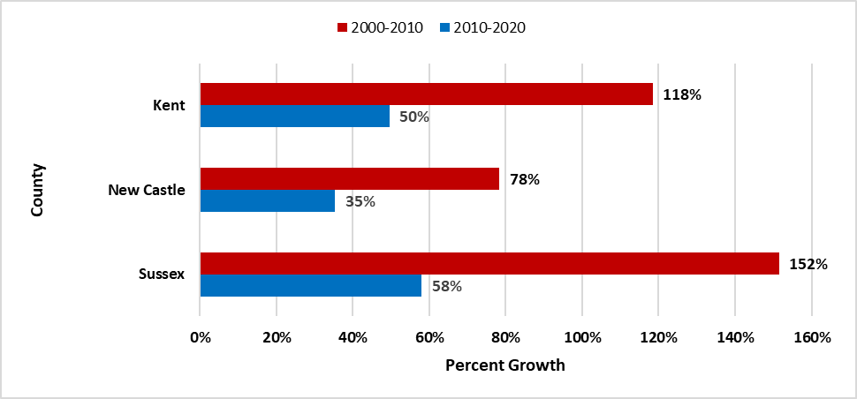

*Source: U.S. Census Bureau 2020,* [*https://data.census.gov/*](https://data.census.gov/)

Specific issues that suggest that Hispanic cancer rates could be subject to misinterpretation are discussed below:

* **Uncertain estimate of Delaware’s Hispanic population —** Estimates of Delaware’s population are derived from the census performed every 10 years by the U.S. Census Bureau and a final adjustment based on projections from the U.S. Census Bureau as to the overall rate of growth for the Hispanic population in both the state and the nation.
* **Inaccurate recording of Hispanic ethnicity on death certificates —** Race and Hispanic origin are treated as distinct categories and reported separately on death certificates and to the Delaware Cancer Registry, in accordance with guidelines from the federal Office of Management and Budget. However, it is possible that Hispanic race is under-reported both in the cancer registry and on death certificates.
* **Hispanic identification in the Delaware Cancer Registry data** **—** The North American Association of Central Cancer Registries (NAACCR) convened an expert panel in 2001 to develop a best practices approach to Hispanic identification. In the resulting approach to enhance Hispanic identification, the NAACCR Hispanic Identification Algorithm (NHIA) was computerized and released for use by central cancer registries in 2003. In this report, NHIA is used to identify Delawareans of Hispanic origin. To minimize misclassification, the expert panel continues to evaluate the NHIA while considering the possibility of the under- or over-estimation of Hispanic cancer incidence.
* **Small number of cases or deaths and small population sizes —** An incidence or mortality rate is an estimate, and the reliability of estimates can be measured by calculating a confidence interval. A narrow confidence interval suggests that the rate is a good estimate; a wide confidence interval suggests that the rate should be interpreted with caution. If the confidence intervals of two rates do not overlap, the rates are considered to be statistically different. Both the size of the numerator (the number of cases or deaths) and the size of the denominator (the population) determine the width of the confidence interval. Typically, researchers report 95% confidence intervals. When constructed properly, a 95% confidence interval includes the true cancer rate 95% of the time.

# Appendix D: Early Detection

## Female Breast cancer Screening Recommendations

A screening mammogram (x-ray of the breast) is used to detect breast disease in females who appear to have no breast problems. For early breast cancer detection in females without breast symptoms, the Delaware Cancer Consortium (DCC) recommends that:36

* Females 40 years of age and older should get a mammogram and clinical breast exam annually.
* Females 25 years of age and older should get a clinical breast exam annually.

The American Cancer Society suggests females are aware how her breast feel and look. If changes occur, these changes should be reported to her health care provider.[35] Females at increased risk for breast cancer should discuss with their health care provider the benefits and limitations of beginning mammograms when they are younger, having additional tests, and/or having more frequent exams.

## Female Breast Cancer Screening in Delaware

The Behavioral Risk Factor Survey (BRFS) has collected yearly mammogram use data through 2000; after 2000, mammogram use data are collected biennially. The BRFS asks a female respondent about her receiving a mammogram during the previous two years (as opposed to the annual mammogram screening schedule recommended by the DCC) to account for minor variations in scheduling that may cause a woman to miss the one-year threshold (e.g., two mammogram screening appointments 14 months apart).

Data from the 2022 BRFS provides information on breast cancer screening among Delaware females:

* Of Delaware females 40 years of age and older, 74% reported having a mammogram within the previous two years, compared to a national median of 70%.  Delaware females ranked seventh highest nationally for this response.
* In Delaware, the percentage of non-Hispanic White females 40 years of age and older who reported having a mammogram in the past two years was slightly lower compared to non-Hispanic Black females.  The difference was not significantly different (73% versus 79%, respectively).
* Delaware females 40 years of age and older in the two highest income categories had the highest percentages of mammography use (74% for females with an annual household income between $25,000 to $34,999 and 77% for females with an annual income of $50,000 or more).
* Delaware females (40 years of age and older) who were college graduates (78%) had a higher prevalence of having had a mammogram in the past two years, compared to Delaware females who had less than a high school diploma (48%); this difference was statistically significant.

**Cervical Cancer Screening Recommendations**

In 2020, the American Cancer Society (ACS) updated their recommendations for cervical cancer screening. Their recommendations are that “individuals with a cervix initiate cervical cancer screening at age 25 and undergo primary HPV testing every 5 years through age 65 (preferred). If primary HPV testing is not available, individuals aged 25-65 years should be screened with co-testing (HPV testing in combination with cytology) every 5 years or cytology alone every 3 years (acceptable) (*strong recommendation*)”*. Additionally, “The ACS recommends that individuals with a cervix who are older than age 65, who have no history of cervical intraepithelial neoplasia grade 2 or a more severe diagnosis within the past 25 years, and who have documented adequate negative prior screening in the 10-year period before age 65 discontinue cervical cancer screening with any modality (*qualified recommendation*)”*.[36] A Pap test is conducted as part of cervical cancer screening.[37]

*A strong recommendation conveys the consensus that the benefits of adherence to that intervention outweigh the undesirable effects that may result from screening. Qualified recommendations indicate there is clear evidence of benefit of screening but less certainty about the balance of benefits and harms or about patients' values and preferences, which could lead to different decisions about screening.”

**Cervical Cancer Screening in Delaware**

The BRFS has collected data on cervical cancer screening in Delaware annually from 1995 to 2000 and biannually since then.  In 2022 the BRFS showed that:

* Fifty-two percent of Delaware women aged 21 to 65 years reported that they had had a Pap test within the previous three years, compared to the nation median of 78% among U.S. women of the same ages.  Delaware ranked 10th highest among all states.
* In Delaware, the prevalence of receiving a Pap test in the past three years was not different when comparing non-Hispanic White females and non-Hispanic Black females (74% vs. 85%, respectively).
* Delaware women aged 21 to 39 had about the same prevalence (83%) of receiving a Pap test in the past three years.  The prevalence increases to 75% among Delaware women aged 40 to 65.
* In Delaware, women aged 21 to 65 years with an annual household income of less than $25,000 (67%) had the lowest prevalence of receiving a Pap test within the past three years.  Delaware women aged 21 to 65 with an annual household income of $50,000 or more (80%) had the highest prevalence of receiving a Pap test within the past three years.
* Seventy-four percent of Delaware women with a high school diploma or less reported having a Pap test within the past three years.  The percentage of Delaware women reporting having a Pap test in the past three years was slightly higher for women with a college degree (86%).  This difference between the lowest educational attainment category and the highest educational attainment category was not statistically significant.

## Colorectal Cancer Screening Recommendations

The ACS and Delaware Cancer Consortium (DCC) colorectal cancer screening guidelines recommend that at 50 years of age, males and females at average risk of developing colorectal cancer should use one of the following screening options:[38]

1. Fecal occult blood tests (FOBT) every year.
2. Fecal immunochemical test (FIT) every year.
3. Flexible sigmoidoscopy every five years.
4. Double-contrast barium enema every five years.
5. Computed tomography (CT) colonography (virtual colonoscopy) every five years.
6. Colonoscopy every 10 years.

For options ‘a’ through ‘e,’ a follow-up colonoscopy should be performed if results from an initial screening test are positive. ACS and DCC screening guidelines offer suggested screening schedules for individuals with an elevated risk of developing colorectal cancer. A risk calculator can be used by the physician. This calculator uses age, gender, race and ethnicity, height, weight, diet and physical activity, medical and family history to determine risk status.

## Colorectal Cancer Screening in Delaware

Data from the 2022 BRFS provides information on colorectal cancer screening patterns among Delawareans:

* Delaware ranked 12th highest in the prevalence (70%) of adults aged 45 to 74 years who reported meeting the U.S. Preventive Services Task Force (USPSTF) recommendations for colorectal screening.  The U.S. national median for meeting the USPSTF recommendation for colorectal cancer screening was 67%.
* The percentage of Delawareans who met the USPSTF recommendation for colorectal cancer screening increased by age group.  Significantly more Delawareans aged 55 to 64 years and aged 65 to 75 years (76% and 82%, respectively) reported meeting the recommendation, compared to those aged 45 to 54 years (47%).
* The prevalence of non-Hispanic White adults aged 50 to 74 years in Delaware who met the USPSTF recommendation for colorectal cancer screening (72%) was lower compared to the prevalence for non-Hispanic Black Delawareans (68%).  However, this difference was not statistically significant.
* In Delaware, the prevalence of adults aged 45 to 74 years who met the USPSTF colorectal cancer screening increased by education level.
* As income increases, so does the prevalence of meeting the USPSTF recommendation for colorectal cancer screening: 58% of Delaware adults in the lowest income category (less than $15,000 annual household income) reported meeting the USPSTF recommendation, compared to 70% in the highest income category ($50,000 or more).

## Lung Cancer Screening Recommendations

In May 2021, the ACS published new lung cancer screening guidelines[39] that recommend that doctors discuss screening options with patients who meet certain criteria for high risk of developing the disease.  High-risk patients are defined as those who are aged 50 to 80 years and have a smoking history equivalent to a pack a day for 20 years or longer or currently smoke or have quit within the past 15 years.

If a high-risk individual decides to be screened for lung cancer, the ACS recommends that the testing be performed using a low dose CT scan at a facility with experience in lung cancer screening.  The guidelines emphasize that screening is not a substitute for quitting smoking.

## Lung Cancer Screening in Delaware

Data from the 2022 BRFS provides information on lung cancer screening patterns among Delawareans:

* It is estimated that approximately 8% of Delaware adults between the ages of 50 and 80 may be eligible for lung cancer screening.
* The vast majority of Delaware adults eligible for lung cancer screening are non-Hispanic White adults. Therefore, breakdowns by race/ethnicity cannot be reported.
* Of Delaware adults eligible for lung cancer screening, only 24% reported having a CT scan to screen for lung cancer.
* Of Delaware adults eligible for lung cancer screening, there were no differences between Delaware males and Delaware females who reported having a CT scan to screen for lung cancer.
* Due to the low percentage of Delaware adults who are eligible being screened for lung cancer, breakdowns by annual household income and educational attainment cannot be reported due to small sample size.

## Prostate Cancer Screening Recommendations

The ACS recommends that males make an informed decision with their health care provider about whether to be screened for prostate cancer.  Males should receive information from their doctors about the risks and possible benefits of prostate cancer screening.  Males should not be screened unless they receive this information.[40]

The DCC recommends the following prostate cancer screening guidelines for Delaware males:

* No population wide prostate cancer screening efforts.
* Promote education for informed prostate cancer screening decision-making.
* Screening in males older than 75 years of age is less desirable; however, screening decisions should be made on an individual basis.
* Screening is not recommended for males with a life expectancy of less than 10 years.
* Offer screening for individuals considered to be at average risk for the disease beginning at 50 years of age, using an informed decision-making process.
  + High-risk individuals should be encouraged to be screened starting at 40 years of age if they:
    - Have first-degree relatives with prostate cancer.
    - Are non-Hispanic Black males.
    - Have family or personal history of BRCA1 or BRCA2 gene.
* Screening at one- to two-year intervals via prostate specific antigen (PSA) test, with or without digital rectal exam (DRE).

## Prostate Cancer Screening in Delaware

Data from the 2022 BRFS provides information on the prevalence of prostate cancer screening among Delaware males:

* Thirty percent of Delaware males 40 years of age and older reported having had a PSA blood test in the past two years. PSA screening questions were not asked in all states and therefore, no national comparisons are available.
* The prevalence of Delaware males who received a PSA test within the past two years increased with age: 30% of males aged 50 to 59 years were tested, compared to 51% of males aged 65 years and older.  This difference was statistically significant.
* In Delaware, there was no statistically significant difference in the prevalence of having a PSA test within the past two years between non-Hispanic White males (35%) and non-Hispanic Black males (34%).
* As the level of education increased, the prevalence of Delaware males who had a PSA test within the past two years also increased.  Only 19% of Delaware males with less than high school education reported having a PSA test within the past two years, compared to 40% of Delaware males who graduated from college.  This difference was statistically significant.

# Appendix E: Behavioral Risk Factors

### **Current Trends in Cigarette Smoking in Delaware**

The Behavioral Risk Factor Survey (BRFS) collects data annually on tobacco use among the Delaware population.  Current smoking trends may be predictive of cancer rates in the 2030s.  In the 1980s, the time period relevant to current lung cancer rates in terms of tobacco use behaviors, Delaware’s smoking prevalence rates were among the highest in the country.  Historical BRFS data show that in 1982, 30% of adult Delawareans smoked cigarettes.  By the 1990s, Delaware’s smoking prevalence among adults had declined to approximately 25%.

In recent years, tobacco use prevalence has continued to slowly decline among adult Delawareans and among high school students.  In 2022, 13% of adult Delawareans smoked cigarettes regularly.  The following data highlights smoking trends in Delaware in 2022:

* The prevalence for current smokers in Delaware (13%) is almost the same as the 2022 U.S. median prevalence of 14%.
* Delaware adult males (14%) had a slightly higher current smoking prevalence compared to Delaware females (12%). This difference was not statistically significant.
* There were no differences in current smoking prevalence among non-Hispanic White adults (14%) and non-Hispanic Black adults (15%) in Delaware.
* When smoking prevalence was stratified by age group, Delawareans aged 35 to 44 reported the highest prevalence of current smoking (22%).  This prevalence was statistically significantly higher compared to that for Delawareans 65 years of age and older.
* Current smoking prevalence changed with education attainment.  In Delaware, 19% of residents who did not complete their high school education said they were current smokers.  As education level increased, smoking prevalence decreased.  Nineteen percent of Delaware adults who reported having a high school diploma or its equivalent reported being a current smoker, compared to 14% with some post-high school education, and 5% who completed college.
* Current smoking prevalence also decreased with higher income levels.  In Delaware, 24% of Delaware adults with a household income between $15,000 and $24,000 were current smokers.  The lowest smoking prevalence was among those who earned $100,000 to $199,999 per year (9%).

### **Overweight/Obesity**

Being overweight or obese is a risk factor for numerous cancers, including female breast, colorectal, kidney, and uterine cancers.  In addition, being overweight or obese is a major risk factor for other chronic diseases, including coronary heart disease, type 2 diabetes, and stroke.43

The Centers for Disease Control and Prevention (CDC) defines overweight as a body mass index (BMI) from 25 to less than 30 and obese as a BMI equal to or greater than 30.  BMI is calculated using an individual’s height and weight.44  The following data are specific to the 2022 Delaware BRFS:

* In Delaware, 72% of adults aged 18 years and older were overweight or obese in 2022, compared to the national median of 68%.
* In 2022, the prevalence of being overweight in Delaware differed significantly by sex:  40% of males and 28% of females were overweight.
* The prevalence of obesity among adult Delawareans did not differ by sex:  35% of adult males and 41% of adult females were obese in 2021.
* In 2022, the prevalence of being overweight was the same for non-Hispanic White (36%) and non-Hispanic Black (27%) Delawareans.
* In Delaware, non-Hispanic Black adults (49%) had a higher prevalence of obesity than non-Hispanic White adults (36%) in 2021.  This difference was statistically significant.
* In 2022, the prevalence of being overweight was highest among Delaware college graduates (37%).
* In 2022, as education increased, the prevalence of obesity decreased.  However, there were no statistically significant differences among educational attainment groups.
* In 2022, there were no significant differences in obesity among those with different annual household incomes; adults with annual household income between $15,000 and $24,999 had the highest obesity prevalence (45%).
* Among Delawareans in 2022, the prevalence of obesity was highest among those aged 45 to 54 years (45%).

### **Physical Activity**

Lack of physical activity is a substantiated risk factor for colorectal cancer and a suspected risk factor for other cancers.45 The benefits of regular, sustained physical activity includes reduced risk for chronic diseases including coronary heart disease, stroke, and type 2 diabetes; and improved well-being.46

The 2022 Delaware BRFS asks a question about participating in any physical activities in the past month.

The following data are from the 2022 Delaware BRFS:

* In Delaware, 77% of adults 18 years of age and older participated in any physical activities in the past month, similar to the national median of 77%.
* There was no difference in physical activity by race/ethnicity.  In 2022, 79% of non-Hispanic White adults, 74% of non-Hispanic Black adults, and 70% of Hispanic adults participated in physical activity in the past month.
* Significantly more college graduates participated in physical activity compared to any other educational attainment.  In 2022, 85% of college graduates participated in physical activity, compared to 78% of adults with some post-high school education and 72% of adults with a high school diploma or GED.  Likewise, statistically fewer Delaware adults with less than a high school diploma (63%) participated in physical activities in the past month.
* Delawareans in lower income categories reported a statistically significantly lower prevalence of participating in physical activities in the past month (52% of those earning less than $15,000; 60% of those earning $15,000 to $24,999 did not meet the guidelines).  This compares to Delawareans in the highest income category, where 90% of those earning $200,000 or more per year participated in physical activities in the past month.

### **Dietary Fruits and Vegetables**

A diet high in fruits and vegetables is a protective factor against numerous cancers, including cancers of the breast, cervix, colon and rectum, uterus, esophagus, oral cavity, ovary, pancreas, prostate, and stomach. These questions are asked every other year.[41]

The following data are from the 2021 Delaware BRFS (the most recent year available):

* In Delaware, 40% of adults consumed fruit less than one time per day, the same as the national median (40%).
* In 2021, 39% of Delaware adult females consumed fruit less than one time per day, compared to 43% of Delaware adult males. This difference was not statistically significant.
* There were no differences observed by race/ethnicity for fruit consumption: 41% of non-Hispanic White adults, 40% of non-Hispanic Black adults, and 31% of Hispanic adults consumed fruit less than one time per day.
* In Delaware, 21% of adults consumed vegetables less than one time per day, almost the same as the national median (20%).
* Delaware adult females reported consuming vegetables more often per day than Delaware adult males. In 2021, 26% of Delaware adult males consumed vegetables less than one time per day, compared to 16% of Delaware adult females.
* There were differences in daily vegetable consumptions by race/ethnicity groups. Only 16% of Delaware non-Hispanic White adults reported consuming vegetables less than one time per day, compared to 28% of non-Hispanic Black adults and 44% of Hispanic adults. The difference between non-Hispanic White adults and non-Hispanic Black adults and Hispanic adults was significantly different.

1. <https://seer.cancer.gov/statistics/types/incidence.html>
2. <https://seer.cancer.gov/statistics/types/mortality.html>
3. <http://delcode.delaware.gov/title16/c032/index.shtml>
4. <https://www.cdc.gov/national-program-cancer-registries/contact/?CDC_AAref_Val=https://www.cdc.gov/cancer/npcr/registries.htm>
5. <https://www.naaccr.org/certification-criteria/>
6. National Cancer Institute, Surveillance, Epidemiology, and End Results Program: Impact of COVID on 2020 SEER Cancer Incidence Data, <https://seer.cancer.gov/data/covid-impact.html>
7. CI*Rank: Ranked Incidence and Mortality Rates by State, County, and Special Region from <https://surveillance.cancer.gov/cirank/>
8. Centers for Disease Control and Prevention. (2024, June 13). *Suppression of Rates and Counts*. United States Cancer Statistics (USCS). Retrieved October 8, 2024, from <https://www.cdc.gov/united-states-cancer-statistics/technical-notes/suppression.html?CDC_AAref_Val=https://www.cdc.gov/cancer/uscs/technical_notes/stat_methods/suppression.htm>
9. Coughlin SS, Clutter GG, Hutton M. Ethics in Cancer Registries. *Journal of Cancer Registry Management, 2:* 5-10, 1999.
10. McLaughlin CC. Confidentiality protection in publicly released central registry data. *Journal of Cancer Registry Management, 2:* 84-88, 2002.
11. U.S. Cancer Statistics Working Group. U.S. Cancer Statistics Data Visualizations Tool, based on November 2022 submission data (1999-2020): U.S. Department of Health and Human Services, Centers for Disease Control and Prevention and National Cancer Institute; [www.cdc.gov/cancer/dataviz](http://www.cdc.gov/cancer/dataviz), June 2023.
12. U.S. Cancer Statistics Working Group. U.S. Cancer Statistics Data Visualizations Tool, based on 2021 submission data (1999-2019): U.S. Department of Health and Human Services, Centers for Disease Control and Prevention and National Cancer Institute; [www.cdc.gov/cancer/dataviz](http://www.cdc.gov/cancer/dataviz), released in June 2022.
13. National Cancer Institute, Surveillance, Epidemiology, and End Results Program: Impact of COVID on 2020 SEER Cancer Incidence Data, <https://seer.cancer.gov/data/covid-impact.html>
14. Fritz A, Jack A, Parkin DM, Percy C, Shanmugarathan, Sobin L, Whelan S (eds). International Classification of Diseases for Oncology, Third Edition (ICD-O-3). World Health Organization, Geneva.
15. Surveillance, Epidemiology, and End Results (SEER) Program (www.seer.cancer.gov) SEER*Stat Database: Mortality - All COD, Aggregated Total U.S. (1990-2020) <Katrina/Rita Population Adjustment>, National Cancer Institute, DCCPS, Surveillance Research Program, released June 2022. Underlying mortality data provided by NCHS ([www.cdc.gov/nchs](http://www.cdc.gov/nchs))
16. National Cancer Institute. (n.d.). *Download U.S. population data - seer population data*. Surveillance, Epidemiology, and End Results Program. Retrieved August 23, 2023, from <https://seer.cancer.gov/popdata/download.html>
17. [United States Cancer Statistics: Data Visualizations](https://gis.cdc.gov/Cancer/USCS/?CDC_AA_refVal=https%3A%2F%2Fwww.cdc.gov%2Fcancer%2Fdataviz%2Findex.htm#/AtAGlance/), Footnotes, Centers for Disease Control and Prevention
18. [United States County Population Data, 1969-2020](https://seer.cancer.gov/popdata/download.html), National Cancer Institute, cancer.gov
19. Behavioral Risk Factor Surveillance System, [http://www.cdc.gov/BRFS/](http://www.cdc.gov/brfss/)
20. Delaware Behavioral Risk Factor Survey: Changing to meet new challenges, <https://www.dhss.delaware.gov/dhss/dph/dpc/brfs_changes2011.html>
21. Behavioral Risk Factor Surveillance System (BRFS) Fact Sheet: Raking, <http://www.dhss.delaware.gov/dph/dpc/files/rakingweights_info.pdf>
22. Delaware Behavioral Risk Factor Survey: Changing to meet new challenges, <https://www.dhss.delaware.gov/dhss/dph/dpc/brfs_changes2011.html>
23. Delaware Behavioral Risk Factor Survey, Measuring Behaviors that Affect Health, <http://www.dhss.delaware.gov/dph/dpc/brfsurveys.html>
24. Anderson RN, Rosenberg HM. Report of the second workshop on age adjustment. National Center for Health Statistics. Vital Health Stat 4(30). 1998.
25. Klein RJ, Schoenborn CA. Age Adjustment Using the 2000 Projected U.S. Population. Healthy People statistical notes, no. 20, <http://www.cdc.gov/nchs/data/statnt/statnt20.pdf>
26. <https://surveillance.cancer.gov/joinpoint/>
27. Surveillance, Epidemiology and End Results (SEER) Program, National Cancer Institute. SEER*Stat Software, Version 8.3.5, <http://seer.cancer.gov/seerstat/index.html>
28. Tiwari RC, Clegg LX, Zou Z. Efficient interval estimation for age-adjusted cancer rates. Stat Methods Med Res 2006;15(6):547-69.
29. Martin JA, Hamilton BE, Ventura SJ, Menacker F, Park MM, Sutton PD. Births: Final data for 2001. National vital statistics reports; vol. 51 no. 2. Hyattsville, Maryland: National Center for Health Statistics, 2002.
30. Centers for Disease Control and Prevention. (2024, June 13). *Suppression of Rates and Counts*. United States Cancer Statistics (USCS). Retrieved October 8, 2024, from <https://www.cdc.gov/united-states-cancer-statistics/technical-notes/suppression.html?CDC_AAref_Val=https://www.cdc.gov/cancer/uscs/technical_notes/stat_methods/suppression.htm>
31. Coughlin SS, Clutter GG, Hutton M. Ethics in Cancer Registries. *Journal of Cancer Registry Management, 2:* 5-10, 1999.
32. McLaughlin CC. Confidentiality protection in publicly released central registry data. *Journal of Cancer Registry Management, 2:* 84-88, 2002.
33. CI*Rank: Ranked Incidence and Mortality Rates by State, County, and Special Region from <https://surveillance.cancer.gov/cirank/>
34. Grieco, EM, Cassidy RC. (2001-03). ["Overview of Race and Hispanic Origin: Census 2000 Brief"](https://www.census.gov/library/publications/2001/dec/c2kbr01-01.html) U.S. Census Bureau. Accessed May 26, 2011.
35. American Cancer Society. (2019, January 24). *Breast cancer screening guidelines faqs: FAQ breast cancer*. Breast Cancer Screening Guidelines FAQs | FAQ Breast Cancer | American Cancer Society. <https://www.cancer.org/cancer/types/breast-cancer/frequently-asked-questions-about-the-american-cancer-society-new-breast-cancer-screening-guideline.html>
36. Fontham ETH, Wolf AMD, Church TR, Etzioni R, Flowers CR, Herzig A, Guerra CE, Oeffinger KC, Shih YT, Walter LC, Kim JJ, Andrews KS, DeSantis CE, Fedewa SA, Manassaram-Baptiste D, Saslow D, Wender RC, Smith RA. Cervical cancer screening for individuals at average risk: 2020 guideline update from the American Cancer Society. CA Cancer J Clin. 2020 Sep;70(5):321-346. doi: 10.3322/caac.21628. Epub 2020 Jul 30. PMID: 32729638. <https://acsjournals.onlinelibrary.wiley.com/doi/full/10.3322/caac.21628>
37. The Pap (Papanicolaou) Test, [https://www.cancer.org/cancer/cervical-cancer/detection-diagnosis-staging/screening-tests/pap-test.html](https://www.cancer.org/cancer/cervical-cancer/detection-diagnosis-staging/screening-tests/pap-test.html%20%20) 
38. Detailed screening guidelines for colorectal cancer, <https://www.cancer.org/cancer/types/colon-rectal-cancer/detection-diagnosis-staging/acs-recommendations.html>
39. Lung Cancer: Screening, <https://www.uspreventiveservicestaskforce.org/uspstf/recommendation/lung-cancer-screening>
40. Prostate Cancer: Screening, <https://www.uspreventiveservicestaskforce.org/uspstf/recommendation/prostate-cancer-screening>
41. National Cancer Institute. (2023, August). *Cancer Trends Progress Report: Fruit and vegetable consumption*. Fruit and Vegetable Consumption. <https://progressreport.cancer.gov/prevention/fruit_vegetable>