Managing your Approved Parental Leave Case
Once your Parental Leave request has been approved, you can view the amount you are paid each cycle on your timesheet by logging into eSTAR. Click on My Timesheet.

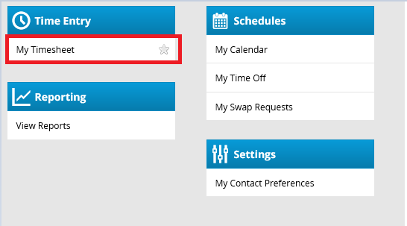

The LOA Leave of Absence paycode tracks FMLA hours and will appear on your timesheet if you are on FMLA and Parental Leave concurrently. This paycode should never be removed from the timesheet by managers or auditors.

The FPLA Paid Parental Leave – Amount pay code and the amount of Parental Leave that you will be paid during the pay cycle will appear on a Sunday if Paid Parental Leave begins on the first day of the week. Otherwise, it will appear on the first day that Paid Parental Leave begins.

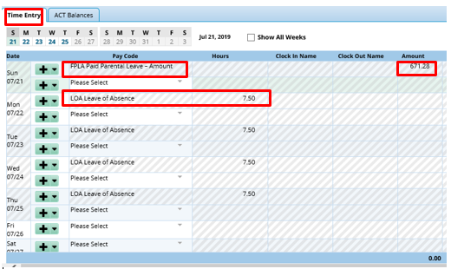

All FMLA cases have a case number assigned to them, and this will appear on the timesheet.

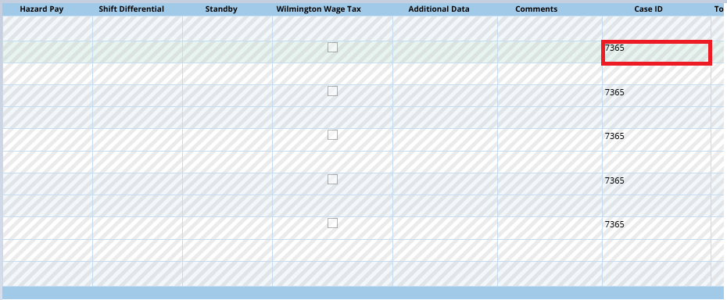

Below is what your timesheet will look like if you are only on Parental Leave.

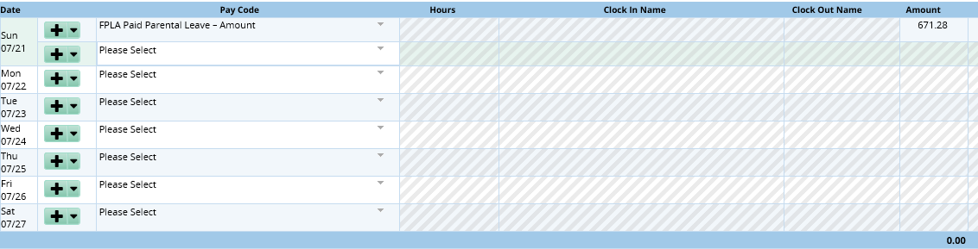

Below is what the results tab will look like.

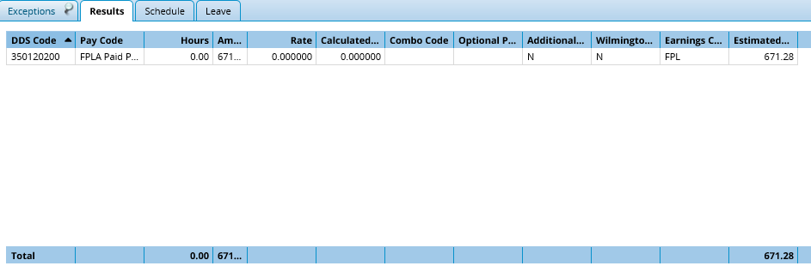

Leave hours should not be decrementing from your leave banks while you’re on Parental Leave.

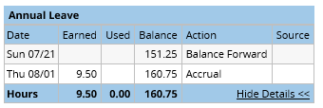
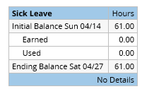

Click on Results.

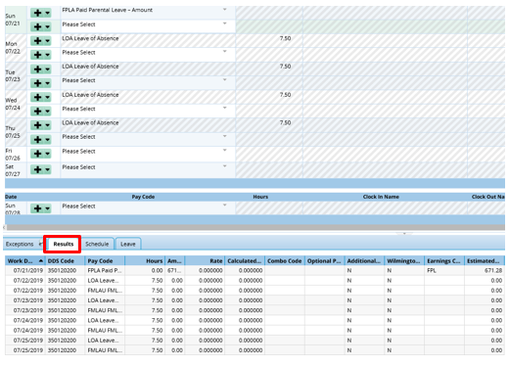

The results tab displays the LOA pay code and the FPLA Paid Parental Leave – Amount pay code. Click on the far right arrow. Uncheck the Work Date box.

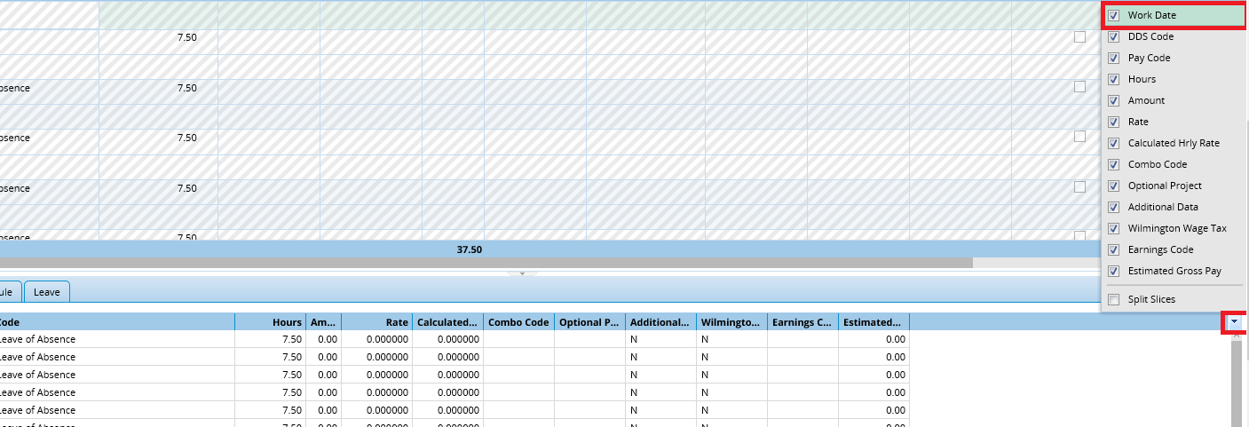

Unchecking this box will display the total amount of leave paid for each pay cycle.

