DHSS Job Aid: How to Start the Parental Leave Process and Update FMLA Questions

When requesting Parental Leave, the Parental Leave Request Form and Parental Leave Calendar must be completed. Additionally, FMLA can be requested for one of the three FMLA qualifying reasons: pregnancy/childbirth, child bonding, and child placement. You can request FMLA paperwork through eSTAR. The information is kept confidential and secure, and only the ACT Case Manager Group can access this FMLA information. From your employee dashboard select Schedules > My Time Off.

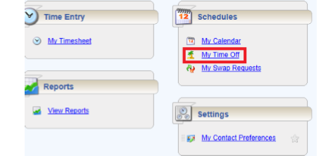

The Request List window appears. Select Create New Request.
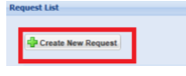

The Create Time Off Request window appears. Choose the FMLA box on the left hand side. Click “Continue” at the bottom for FMLA.

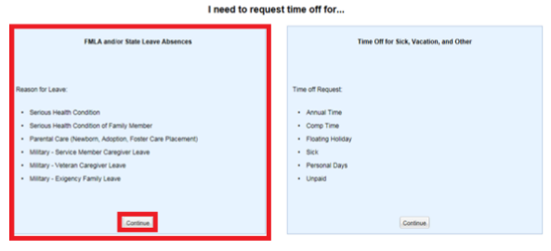

Under the Create New Leave Request section, select the Estimated Start Date and Estimated End Date for your FMLA; both fields must be completed. If the reason for FMLA is pregnancy/childbirth, then the start date must be the date that the child is born.

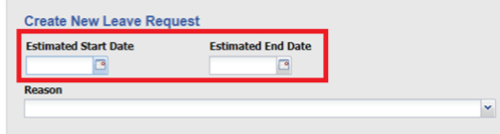

Only select one of the three statements below that provide the Reason you are requesting FMLA.

- I’m pregnant or need time off to deliver my baby.
- I need time to bond with a new child.
- I need time to complete an adoption or foster child placement.

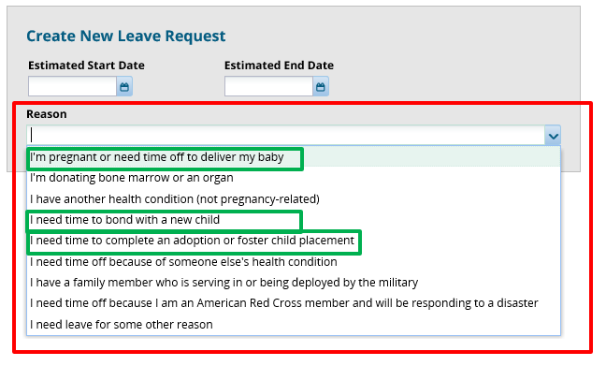

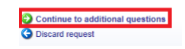
Once you select your date range and reason at the bottom of the page select Continue to additional questions.

The system will prompt you to answer specific questions based on the reason you selected. You may be asked to provide details such as: Expected Due Date, child’s birth date, name of the person you need to provide care, and treating physician’s name and contact information. Your answers to specific questions are necessary in order for the system to evaluate your FMLA eligibility. It is advisable to have prepared answers to specific details requested so that your FMLA request can be evaluated. Once you certify that all the answers to the questions are correct select Submit Request.

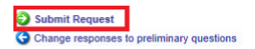

Your case will then be listed as pending. The ACT Case Manager Group will be notified of your case and review it accordingly.

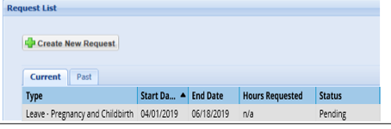

An ACT Case Manager assigned to your case will review your eligibility for FMLA and send you FMLA related documents.
If your FMLA is approved, your FMLA bank will be decremented.
Updating FMLA Questions

Once you have requested FMLA you can log back into the system and edit your answers to FMLA questions while your case remains pending. *You can only edit your answers on a pending case. If you need to change your answers, go to the Request List and double click your pending FMLA case.

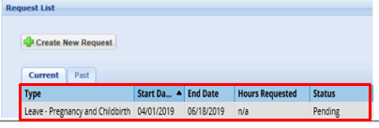

Your absence case will open.

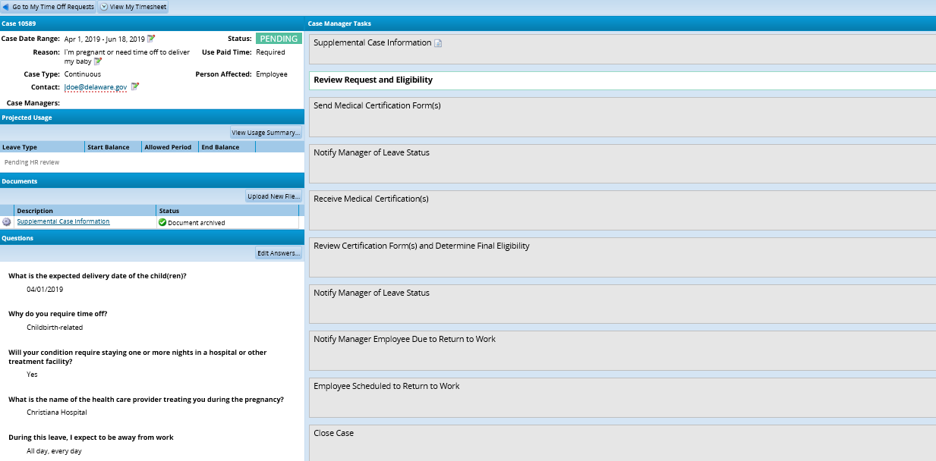

Under Questions select Edit Answers.

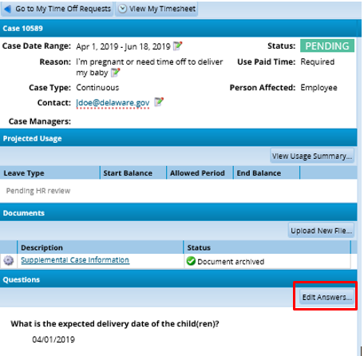
A box will open on your screen. You can edit your answers by clicking on any question you would like to change. Depending on your answer, new questions could be generated. Once you edit your answers to the questions click Close. Your edits have been saved.

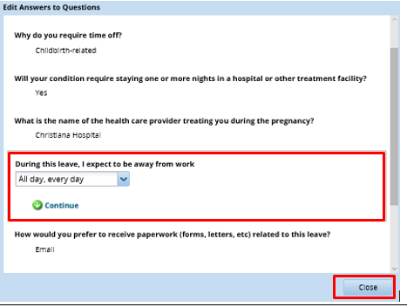
Your case manager will be able to see any changes you made to your pending FMLA case.

