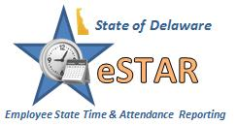

A message from DHSS Human Resources and Payroll—

Please take time to review the DHSS policy that defines roles and responsibilities under the eSTAR system.  The policy, titled “Department of Health and Social Services eSTAR Time and Leave Keeping policy can be found at the DHSS eSTAR website –Policy / Procedure section:  [eStar](http://dhss.delaware.gov/dhss/dms/hrm/estar/estar.html)

This policy is required under the Department of Finance, Division of Accounting Internal Control Requirements that must be filed by each agency and must be reviewed by all employees annually.  The policy provides general system operating procedures and outlines the roles and responsibilities of:

* Employees
* Managers
* Auditors
* eSTAR Coordinators
* Human Resources
* Payroll

Questions may be directed to your local Human Resources group:

|  |  |
| --- | --- |
| **HR Office** | **Phone** |
| New Castle County | 302-255-9070 |
| Kent/Sussex Regional Office | 302-744-4558 |
| DHCI / GBHC | 302-223-1550 |
| Stockley Center | 302-933-3000 |