Travel Advisory – Dengue Virus in Puerto Rico
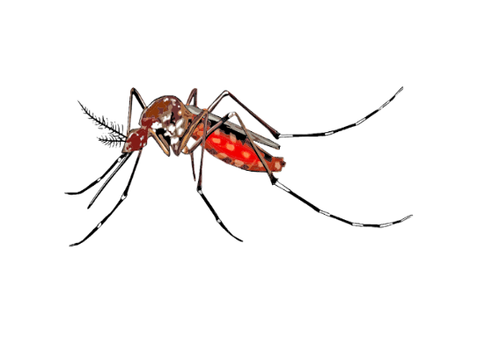
March 28, 2024 – The Puerto Rico Department of Health issued a public health emergency after recording 549 cases since the start of the year, 49% of which have occurred in the San Juan region. If travelling to Puerto Rico, the Delaware Division of Public Health (DPH) urges Delawareans to prevent mosquito bites. Thus far, DPH reported one dengue case with travel to Puerto Rico.
Dengue virus is a mosquito-borne disease that is primarily spread by the bite of Aedes aegypti and Aedes albopictus mosquitoes. These mosquitoes bite during the daytime and lay eggs in containers within urban areas.
Anyone who travels to Puerto Rico can be infected. Many people who are infected with dengue do not develop symptoms. About one in four people infected with the virus develop the disease and symptoms are generally mild. The most common symptoms of dengue are fever, rash, muscle pain, joint pain, bone pain, pain behind the eyes, and nausea/vomiting. Symptoms typically begin two to seven days after being bitten by an infected mosquito. Health care providers should ask all their patients about recent travel.
The best way to reduce your risk of dengue is to avoid mosquito bites.
- Use an EPA-registered insect repellent with DEET, picaridin, IR3535, oil of lemon eucalyptus, para-menthane-diol, or 2-undecanone. Always make sure to follow label instructions.
  - Use the EPA’s search tool to find the insect repellent that is right for you.
- Wear loose-fitting, long-sleeved shirts and pants. You can use 0.5% permethrin to treat clothing and gear. Permethrin is an insecticide that kills or repels mosquitoes.
- For babies and children:
  - Cover strollers and baby carriers with mosquito netting.
  - When applying insect repellent to babies and children, do not apply repellent to their hands, eyes, mouth, cuts, or irritated skin. Adults should apply insect repellent to their hands and then use their hands to apply to a child’s face.
- Sleep under a mosquito bed net if air conditioned or screened rooms are not available or if sleeping outdoors.
For more information on mosquito-borne disease visit: https://dhss.delaware.gov/dhss/dph/epi/mosquito.html

