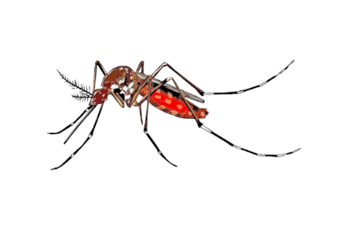
Human West Nile Virus Cases Reported in Every State Surrounding Delaware
According to the Centers for Disease Control and Prevention’s provisional arboviral report, Pennsylvania, Maryland, New Jersey, and Virginia all reported human West Nile virus (WNV) cases in 2024. While there have been no reported WNV cases yet in humans for 2024 in Delaware, we urge healthcare providers, especially in the emergency department, to be vigilant for such cases and ensure that all hospitalized patients with signs of a neuroinvasive disease undergo appropriate testing during the mosquito season. Continue to article

According to the Centers for Disease Control and Prevention’s provisional arboviral report, Pennsylvania, Maryland, New Jersey, and Virginia all reported human West Nile virus (WNV) cases in 2024. While there have been no reported WNV cases yet in humans for 2024 in Delaware, we urge healthcare providers, especially in the emergency department, to be vigilant for such cases and ensure that all hospitalized patients with signs of a neuroinvasive disease undergo appropriate testing during the mosquito season.
It is also important to keep individuals who are homeless on your radar for neuroinvasive WNV. Individuals who are homeless are exposed to mosquitoes at a higher rate than individuals who are not homeless. They may also have underlying risk factors.

The preferred diagnostic test for arboviruses is virus-specific IgM antibodies in serum or cerebrospinal fluid. WNV-specific IgM antibodies are usually detectable 3 to 8 days after onset of illness and persist for 30 to 90 days, but longer persistence has been documented. Therefore, positive IgM antibodies occasionally may reflect a past infection. If serum is collected within 8 days of illness onset, the absence of detectable virus-specific IgM does not rule out the diagnosis of WNV infection, and the test may need to be repeated on a later sample. Also, it is critical that healthcare providers list all symptoms and exposure history in the patient’s medical charts.

If you have a confirmed or suspected case, you should report this to DPH by sending labs and a case report form to reportdisease@delaware.gov, or by calling DPH at (302) 744-4700. Timely reporting allows us to promptly notify Delaware Department of Natural Resources and Environmental Control’s Mosquito Control Section who can better focus their mosquito surveillance and control efforts.

For more information about vector-borne diseases in Delaware, please visit: https://www.dhss.delaware.gov/dhss/dph/epi/vectordisease.html.

